University of Louisville Asian Studies Program, in cooperation with the Center for Asian Democracy presents the
4th Annual Lang Seminar in Asian Studies:

“International Cooperation in South/Southeast Asia”

Saturday, April 5, 2014, Ekstrom Library, Room W104, University of Louisville

SCHEDULE

Continental Breakfast
9:15-9:45am

Morning Session: Southeast Asia
9:45-10:00am – Welcome Remarks: John McLeod, University of Louisville

10:00-10:50am – “Asia’s Shifting Constitutional Landscape: ASEAN, China & the United States,” Alice Ba, University of
Delaware
10:50-11:00am – Commentator: Michael M. Losavio, University of Louisville
11:00-11:15am – Q/A

11:15-12:05am – “Regional Implications of the Globalization of the Chinese Currency,” Michael Martin, U.S. Congressional
Research Service
12:05-12:15pm – Commentator: Kristopher Grady, University of Louisville
12:15-12:30pm – Q/A

Lunch (provided)
12: 30-1:45pm

Afternoon Session: South Asia/India
1:45-2:35pm – “A Billion People Vote: Possible Implications of Indian Elections,” Rina Williams, University of Cincinnati
2:35-2:45pm – Commentator: Patrick Pranke, University of Louisville
2:45-3:00pm – Q/A

3:00-3:50pm – “Indian Views on the Responsibility to Protect,” Sumit Ganguly, Indiana University
3:50-4:00pm – Commentator: Charles Ziegler, University of Louisville
4:00-4:15pm – Q/A

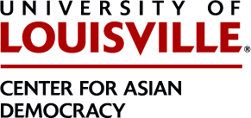
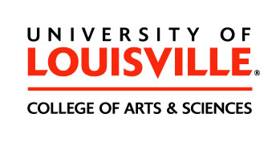
4:15-4:30pm – Concluding Remarks: Shiping Hua, University of Louisville

