The College of Arts and Sciences is committed to building an exemplary educational community that offers an inclusive and equitable intellectual climate. This section of our Monday Memo is designed to increase awareness, understanding, and respect for the range of human diversity throughout the college.

In accordance with the university’s policy on work-restricted religious holidays, we would like to reiterate the importance of allowing students who observe work-restricted religious holidays to do so without jeopardizing their academic standing in any course. Staff and faculty who observe work-restricted religious holidays should be accommodated as well. Individuals who follow and/or observe work-restricted holidays are not permitted to engage in daily work or attend school, which includes taking exams or performing routine duties. For additional information on this policy, please visit: http://louisville.edu/diversity/documents/work-restricted-holy-day-policies-and-calendar.

You are invited and encouraged to display artifacts and observe holy days as you are most comfortable doing so.

December Observances

February 8 Chinese New Year (Confucian, Daoist, Buddhist)

Traditionally, this century old festival is a time to honor deities and ancestors and is considered to be a major holiday. Traditions include family gatherings and cleaning homes in order to sweep away any ill-fortune and to make way for good incoming luck.

For additional information, please visit:

http://www.history.com/topics/holidays/chinese-new-year
February 10 Ash Wednesday (Christian)
Officially named “Day of Ashes”, Ash Wednesday is considered the first day of Lent. Observances include the practice of rubbing ashes on one’s forehead in the sign of a cross. Lent is a time of self-denial, fasting, moderation, and forsaking sinful habits and activities.
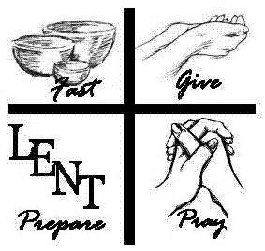
For additional information, please visit:
http://www.catholic.org/clife/lent/ashwed.php

February 15 Nirvana Day (Buddhist, Jain)
This annual festival, also known as Parinirvana Day, remembers Buddha’s death and Nirvana arrival at age 80. Nirvana is believed to be the end of the death cycle and rebirth. According to the teachings of Buddhism, all want and suffering is gone once Nirvana is reached.
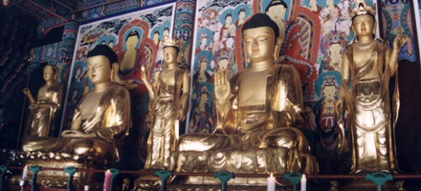
For additional information, please visit:
http://www.buddha101.com/p_nirvana.htm

Did you know this about Valentine’s Day:
http://www.history.com/topics/valentines-day
Interested in engaging with local communities? Feel free to visit the following:

Christian http://www.chiff.com/christmas/christmas-kentucky.htm
Buddhist http://www.planetlouisville.com/Louisville-Buddhism.html
Jainism http://www.hinduwebsite.com/jainism/jainindex.asp
http://www.djsna.com/sitepages/centerlist/default.aspx
http://www.taoist.org/usa/locations/louisville/

What have we missed?
In an effort to be inclusive, we encourage you to share additional information/suggestions about your religious community by contacting Marian R. Vasser in the A&S Dean’s Office for International, Diversity, and Engagement Programs at mrvass01@louisville.edu.

