Create your faculty web profile!
We often feature our A&S faculty in the news. Linking news stories to your profile lets students, donors, and the public learn more about our quality faculty and helps promote research activity in the college.
Contact your department’s web editor or the A&S Web Coordinator jason.seitz@louisville.edu to provide information about your:
- Background / about you
- Research interests
- Education
- Publications
- Curriculum Vitae
- Personal website related to your research
- Social media accounts related to your research
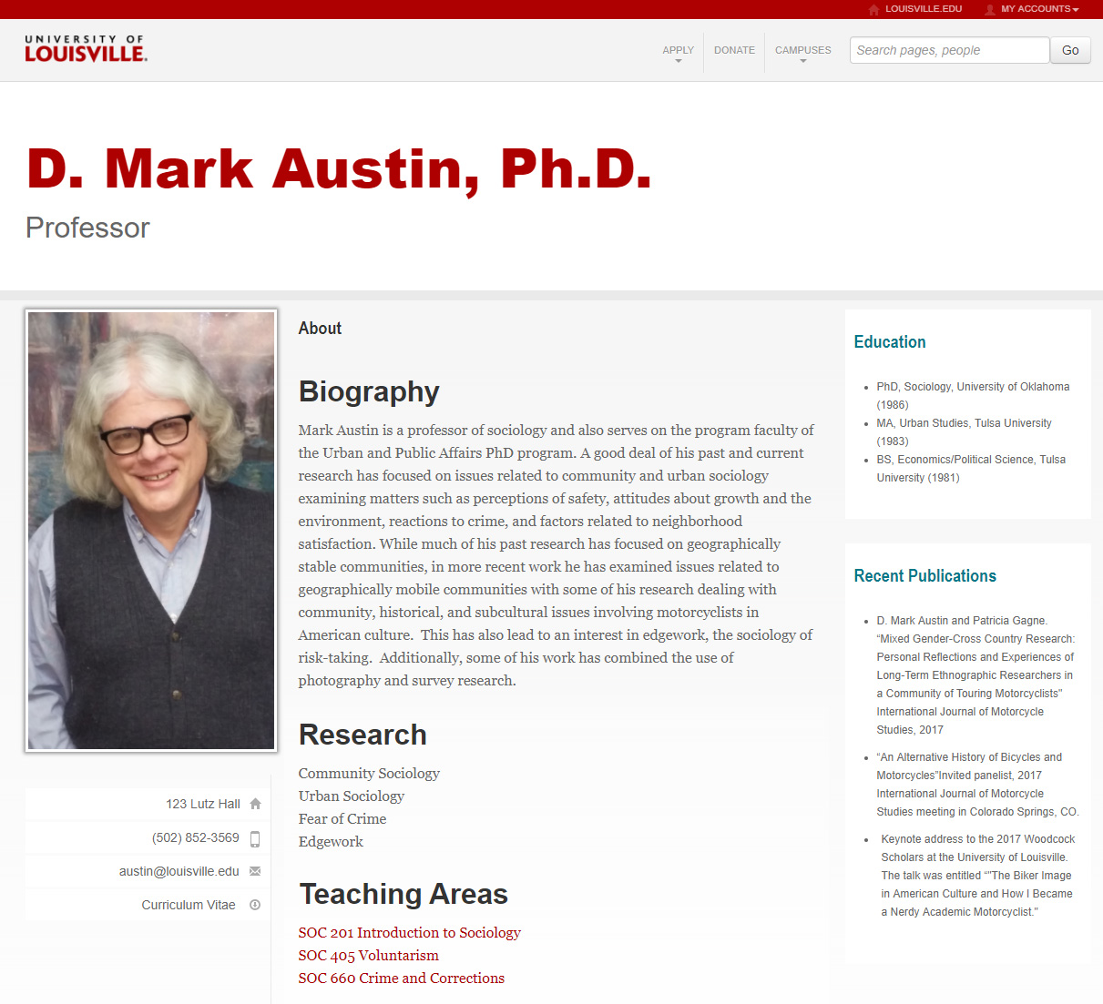

Web contacts by Department
Anthropology  louisville.edu/anthropology  Anthony Hundley  anthony.hundley@louisville.edu  Biology  louisville.edu/biology  Jennifer Mansfield-Jones  j.mansfield-jones@louisville.edu  Chemistry  louisville.edu/chemistry  Jason Sievers  jason.sievers@louisville.edu  Classical and Modern Languages  louisville.edu/modernlanguages  Blanca Ruiz  blanca.ruiz@louisville.edu  Communication  commcourses.com  Al Futrell  allan.futrell@louisville.edu  Comparative Humanities  louisville.edu/humanities  Joshua Boydstun  joshua.boydstun@louisville.eduw  Criminal Justice  louisville.edu/justice  Jason Seitz  jason.seitz@louisville.edu  English  louisville.edu/english  Hung Ngyuen  hung.nguyen@louisville.edu  Fine Arts  louisville.edu/art  Ying Kit Chan  chan@louisville.edu  Geography and Geosciences  louisville.edu/geography  Donald J. Biddle  djbidd01@louisville.edu  Department of History  louisville.edu/history  Jason Seitz  jason.seitz@louisville.edu | Department of Mathematics  louisville.edu/math  Andre Kezdy  andre.kezdy@louisville.edu  Department of Pan African Studies  louisville.edu/panafricanstudies  Jason Seitz  jason.seitz@louisville.edu  Department of Philosophy  louisville.edu/philosophy  Andreas Elpidorou  andreas.elpidorou@louisville.edu  Physics and Astronomy  physics.louisville.edu  Lutz Haberzettl  lutz.haberzettl@louisville.edu  Department of Political Science  louisville.edu/politicalscience  Anthony Hundley  anthony.hundley@louisville.edu  Department of Psychological and Brain Sciences  louisville.edu/psychology  Maria Kondaurova  maria.kondaurova@louisville.edu  Department of Sociology  louisville.edu/sociology  Anthony Hundley  anthony.hundley@louisville.edu  Department of Theatre Arts  louisville.edu/theatrearts  Blair Boyd  brboyd02@louisville.edu  Department of Urban and Public Affairs  louisville.edu/upa  Matthew H. Ruther  matthew.ruther@louisville.edu  Department of Women's and Gender Studies  louisville.edu/wgs  Jason Seitz  jason.seitz@louisville.edu

