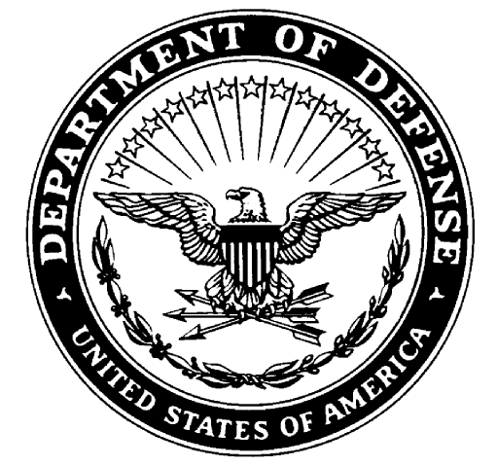
Department of the Army
Seventh Brigade, US army cadet command
university of louisville
dougherty hall room 214
2301 south Third street
louisville, kentucky 40292

reply to
attention of:

atCC-GGk-YUL Date:

MEMORANDUM FOR Professor of Military Science

SUBJECT: Statement of Acknowledgement for Civilian Dental Records

_______ I have verified with my dentist that my dental records do contain descriptive profiles,
bite wing x-rays, orthodontic profiles or dental x-rays for identification purposes.

Dentist Name: ____________________________________ Phone: ______________________

Address: _________________________________________

_________________________________________

_________________________________ ________________________________
(CADET PRINT NAME) (CADET SIGNATURE)

_________________________________
(DATE)

