M.A. socio-cultural anthropology graduate Tyler Short describes his experiences in Rome, Italy

In December 2017 I had the honor of traveling to Rome for two trainings that involved nearly twenty youth from around the world. As a member of Sustainable Agriculture of Louisville (SAL), I represented the US Food Sovereignty Alliance (USFSA), a coalition of grassroots and grassroots-support organizations dedicated to realizing the human right to food sovereignty by ending poverty, rebuilding local economies, and asserting democratic control over food systems.

I.
December 7–8, the Civil Society Mechanism (CSM) for Relations with the UN Committee on World Food Security (CFS) hosted the first meeting of the Youth Constituency. The agenda largely paralleled the Mechanism’s Welcome Kit.
The Secretariat characterizes CSM in terms of: an open and inclusive space; a collective learning process; and an articulation of local, national, regional, and global struggles. CSM launched in 2010 with the reforms to CFS. The Mechanism incorporates eleven global units and seventeen sub-regions with an estimated total of 380 million or more organizational affiliates.

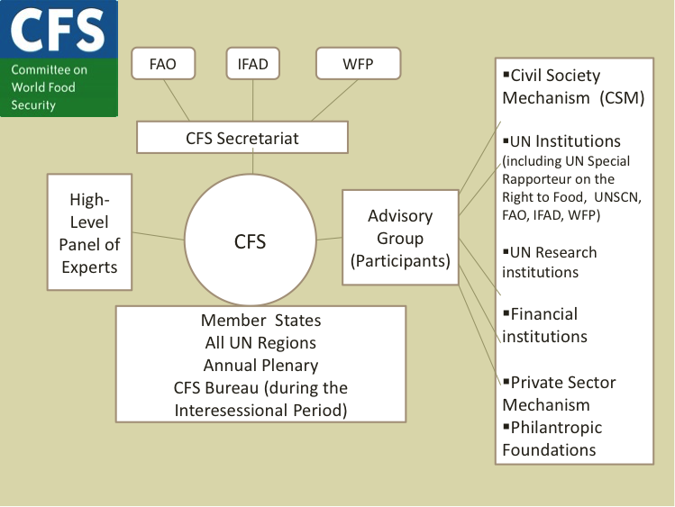
Structure of the reformed CFS

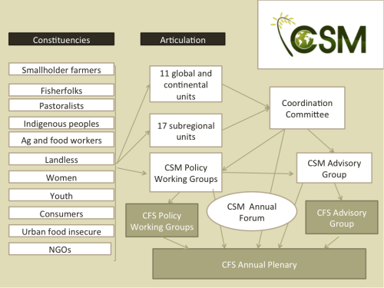
Structure of CSM

Through presentations and Q&A sessions, constituents learned about the histories and structures of CSM and CFS. The CSM Secretariat and guest speaker Nora McKeon provided overviews of policy working groups, particularly the collectives focused on Women, Agroecology, and Connecting Smallholders to Markets. Fernanda Tansini from the Permanent Representation of Brazil in Rome highlighted the efforts of her government over recent decades to eradicate hunger. Participants discussed interconnected points of struggle and began to draft a Youth Vision, which the constituency will eventually present to CFS. Finally, we selected two new members to serve on the CSM Coordinating Committee.
“CFS is at a crossroads,” noted the CSM Secretariat, primarily due to lack of Member State commitment. They recurrently called attention to the red line imposed by the US on the right to food. The Secretariat also pointed out the policy incoherence of CFS, such as the Committee’s advocacy on biotechnology and, more recently, agroecology. Despite inclusion of agroecology in the 2018–2019 work program, CFS rejects any mentioning of food sovereignty.

II.
December 9–12, the International Planning Committee for Food Sovereignty (IPC) hosted a Youth Training for the first time. The attendees included all but one present at the CSM meeting.
IPC is the largest alliance of small-scale producers, who provide 70–80% of the food consumed by humans worldwide. Members subscribe to the principles of food sovereignty, and the autonomous coalition comprises over six thousand organizations with about three hundred million affiliates. In addition to contributing to CFS initiatives via CSM, IPC engages with the UN Food and Agriculture Organization (FAO) under a strategic partnership framework established as an outcome of the 2003 World Food Summit.

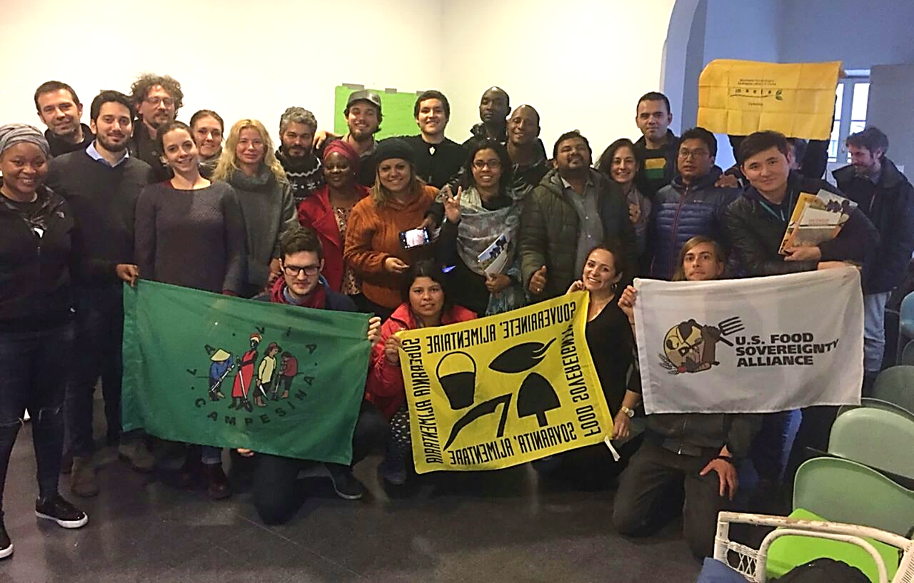
Trainees, IPC organizers, and FAO representatives pose together on Day Three.
Flags held in the photo include: La Via Campesina; IPC; MAELA; and USFSA.

The first and second days of the Youth Training entailed presentations concerning the alliance’s history, structure, and active working groups focused on: agroecology; agricultural biodiversity; fisheries; and land and territories. Early on day three, we devised proposals highlighting what the Youth expect from IPC and FAO. Later, trainees presented to two FAO employees, who then spoke to the group about “decent work” in rural areas and the inclusion of civil society organizations into the reformed CFS.
On the final day, over ten employees and consultants from FAO joined the training space in order to begin a dialogue with the IPC Youth. The meeting included introductions, presentations to FAO, and discussion, which in total spanned over three hours. We situated our proposals into three priority categories that link local and global levels: agroecology; migration and unemployment; and participation of youth in all agri-food policy and governance spaces.

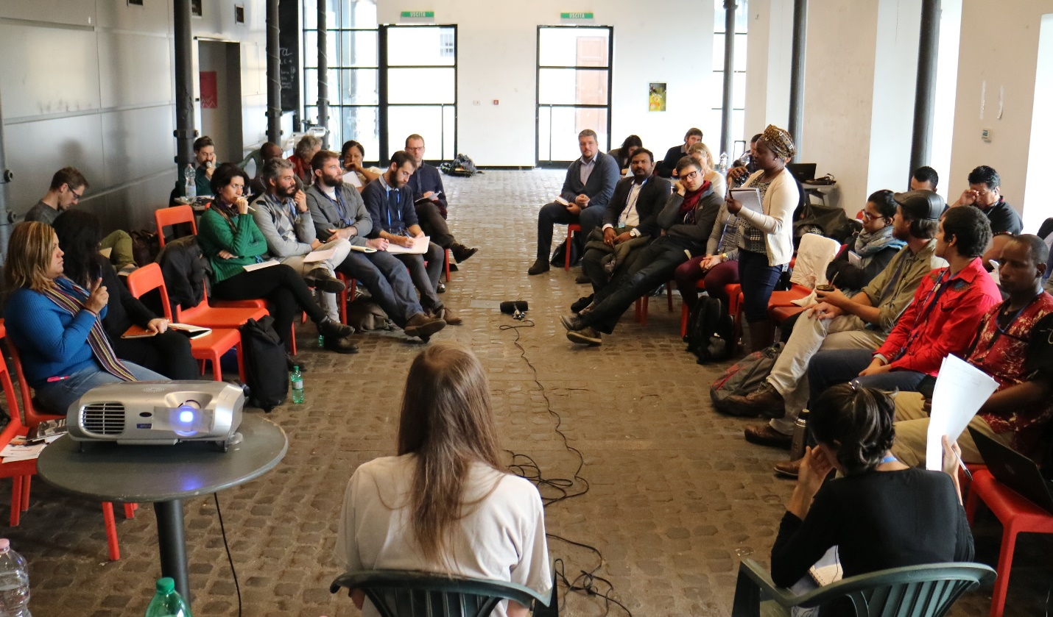
Trainees, organizers, and FAO representatives engage in dialogue on Day Four.
Speaking in the photo is Nzira, a member of World March of Women. Image taken by FAO.

III.
It was a great privilege to make new friends, learn the training content, and gain inspiration from the trainees and organizers. Not since completing my graduate program have I felt such a deep sense of motivation to further pursue scholarly goals and participate in social movements. After the trainings, I began to co-lead a process within USFSA aimed at increasing youth participation in the alliance’s regional and national structures. I plan to enter a doctoral program in the near future, during which I intend to conduct ethnographic research in collaboration with USFSA and international partners.
For more information about the differences between food security and food sovereignty, please see the figure below, which derives from a backgrounder (2010) produced by USFSA member Food First/Institute for Food and Development Policy.

