Stipulation Response Procedure – General

If you are the Primary Investigator, follow these first few steps then go to Step #1:

1. Log into iRIS.
2. On the front page, click “Submission Response”.
3. Click [https://iris-user.louisville.edu/images/Edit.png](https://iris-user.louisville.edu/Application_Main_Modern.jsp) for the IACUC Proposal which has the stipulation(s).  You will be directed to the Review Response Submission Form.

If you are the IACUC Protocol Manager, follow these first few steps (if the views above for the PI are not available) then go to Step #1:

1. Log into iRIS
2. On the front page, click “Study Assistant”.
3. Click “My Studies”.
4. Find the Proposal with “PI Response Required” and click on the notepad under “Click to open”.
5. On the right side of the screen you will find the following :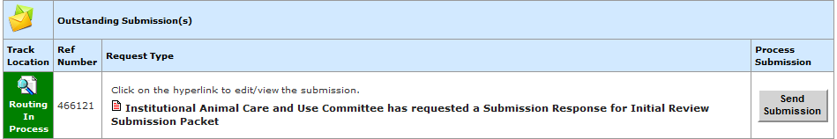 . Click on the “Institutional Animal Care and Use Committee has requested a Submission Response for Initial Review Submission Packet”. You will be directed to the Review Response Submission Form.
6. Navigate to the first stipulation needing to be addressed. Many times the Reviewer has entered an introductory stipulation or comment.
7. Click cid:image002.jpg@01D11313.0AA7A3C0 and click “OK” when the message appears wanting you to confirm that you are creating a revision.  You are now in the section which the Reviewer linked the stipulation.
8. Revise the section as required by the stipulation. Be thorough and clear with the revision. My suggestion would be to contact the Reviewer by email or by a telephone call if there is any question as to what is being required by the stipulation. This may eliminate the need for another round of stipulations and delay in the approval of the Proposal.
9. When the stipulation has been thoroughly and clearly completed, click cid:image012.jpg@01D11313.0AA7A3C0.
10. Click  cid:image013.jpg@01D11313.0AA7A3C0 in the top right corner.  This takes you back to the Review Response Submission Form.
11. Check “Yes” to the question “Do you accept this Stipulation?”  You must do this for each stipulation as this is an iRIS system requirement at this stage in its development.
12. You may then add an explanation as to how you addressed this stipulation in the box provided.  This is not necessary, but it gives you the opportunity to explain what revision you made in the Proposal.
13. Verify the stipulation “Status” appears as this cid:image014.jpg@01D11313.0AA7A3C0.
14. If under “Action” you see  cid:image015.jpg@01D11313.0AA7A3C0, click this to set the status to “Complete”.  Answer “OK” to the message confirming that you want to set this as completed.  The stipulation “Status” now should appear as  cid:image014.jpg@01D11313.0AA7A3C0.
15. Now you may navigate to a different stipulation.
16. Once at the different stipulation, click cid:image016.jpg@01D11313.0AA7A3C0, where “Version 1.?” means whichever version is listed as this will be the latest version created.  You will now be in the section of the revised Proposal where the stipulation needs to be addressed.
17. Repeat steps 3 through 11 as many times as needed to respond to each stipulation.
18. When all stipulations have been answered in the revised Proposal, please verify that each stipulation has been accepted with a “Yes” response, the status is cid:image014.jpg@01D11313.0AA7A3C0, and any stipulation for which you wanted to provide an explanation has been entered.
19. Click cid:image016.jpg@01D11313.0AA7A3C0once more to enter the revised Proposal.
20. On the left side of the screen under “Section view of Application”, click on “End of Form” which is in Section 30.0 of the Proposal.
21. Click cid:image018.jpg@01D11313.0AA7A3C0.  You are now back in the Review Response Submission Form.  This is a critical step as you cannot signoff and submit the revision unless you perform this step.
22. Click cid:image019.jpg@01D11313.0AA7A3C0.
23. Click cid:image020.jpg@01D11313.0AA7A3C0.  You are now on the Signoff Form.
24. Click “Approve” and enter your ULink UserID and Password in the spaces provided.
25. Click cid:image021.jpg@01D11313.0AA7A3C0.
26. You are finished!

Notes:

If you perform step 20 and an error occurs, please check to make sure that each stipulation has been accepted with a “Yes” and the status of each is “Completed”. If not, correct either one of those or both of those errors.

If after you perform step 20 and a validation issue occurs, something within the revision of the Proposal is not correct and will need to be corrected before the signoff process can continue. The validation issues may be handled directly by clicking on the error. You will be taken to the section of the revised Proposal which has the error, usually a box that needs to be checked or a text box which needs to have information entered. Once the error is fixed, follow the directions iRIS gives to complete the signoff.