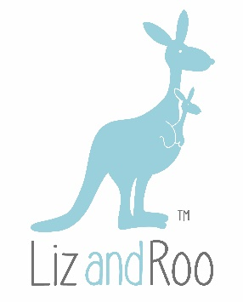

Luxury for Littles

We’re a small, entrepreneurially-spirited company. We design, manufacture, and sell luxury baby bedding and nursery accessories both online and wholesale. We believe in “shop local”. Our sewing operations are in Utah, our custom sewing is out of Louisville, and our goal is to source the majority of our materials in the USA.

Liz and Roo is located in Bakery Square, a 150-year old building in Butchertown in a building that has a lot of old charm (including slanted floors and drafty windows). We are in search of an intern. We’re flexible on hours, but the intern position will be 15-20 hours a week.

This intern will have the opportunity to jump into all aspects of running a small business, including social media research and content development, inventory, customer service, packaging and more. Intern must know Word, Excel, and be proficient in his/her own social media accounts. An interest and talent in writing is also desired as we have a blog!

We need this kind of person!

- Self-motived, ability to learn programs quickly – we’ll train you, but exploring the details on an ongoing basis is something you’ll need to navigate (somewhat) on your own.
- Proficiency in excel and word required.
- Attention to detail and organized – we all wear a ton of different hats. That means juggling a lot of balls at times. The ideal candidate needs to be both organized and flexible. This is not a “rote” internship!
- Social media knowledge/interest – we rely on social media as part of our overall strategy and expect our intern to engage with Liz and Roo on Instagram, FB, etc.
- Interest in fabrics, home décor and nursery design – the candidate does not have to have any design background, but it would be a plus!

