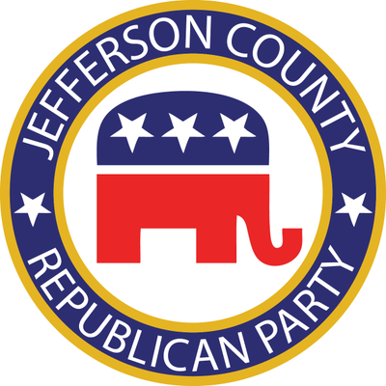
Jefferson County Republican Party
Internship Program

Description: The JCRP internship program intends to give students the opportunity to enhance their civic education, provide real world political and campaign experience, and to develop a deeper understanding of Kentucky politics and party organization. Interns will work with JCRP staff, county party leaders, elected officials and political candidates on projects related to research, fundraising, communications, data, and more. Applicants must be ready for a demanding, fast-paced, and team-oriented environment.

Internships are available in the Spring, Summer, and Fall. During an election year, exact dates may be subject to change.

Spring: February 1 – May 1
Summer: May 15 – August 15
Fall: September 1 – December 1

An intern during the summer should expect to work at least 20 hours per week, while interns during the fall and spring should expect to work at least 10 hours per week.

Qualifications: A successful applicant will have a positive attitude, an ability to meet project deadlines, and possess excellent interpersonal skills. They will also be responsible, detail-oriented, and self-motivated. We encourage students of all academic fields to apply. Individuals who are seeking a college degree are preferred, but opportunities will also be provided for students in High School.

How to Apply: If you are interested in joining our team, please email your résumé, a writing sample, and the following completed application to info@louisvillegop.com with the subject line “Internship Application.”

Jefferson County Republican Party Internship Program
Application Form

Applicant’s Information:
Full Name:

Address:

City: |  | Registered Republican:  (Circle One)  YES NO | Phone:
State: | Zip: |  | Email:

Address Where Registered to Vote: (If Different From Address Listed Above)
Address:

City: | State: | Zip:

Please Choose the Session Which You Would Like To Be Considered For Below:
Summer | Fall | Spring

Dates of Availability:
Proposed Start Date: | Proposed End Date:

Required Application Materials:
Brief Writing Sample  (short paper, letter or article) | Resume | Two References

Please Briefly Answer The Following Questions: (Answer in spaces provided on next page)
- Why are you a Republican?
- What do you hope to gain from interning with RPK?
- How did you get interested in politics? Do you have any previous political experience?
Paid for by the Jefferson County Republican Party and not authorized by any candidate or candidate’s committee.
(502) 584-7111
Answer Previous Questions In Spaces Below.
1.
2.
3.

Paid for by the Jefferson County Republican Party and not authorized by any candidate or candidate’s committee.
(502) 875-5130.

