INTERFOLIO PROMOTION AND TENURE SUBMISSION INSTRUCTIONS

The University of Louisville recently completed implementation of Interfolio’s Review, Promotion, and Tenure software and will be using this online platform to conduct this year’s promotion and tenure process. This online platform will replace the paper binder system used in the past.

What is Interfolio Review, Promotion, and Tenure software?
Interfolio’s Review, Promotion, and Tenure software addresses the full scope of academic promotion and tenure—from submission to a final decision. This software will allow us to move away from the current paper-based binder system to an electronic promotion and tenure system. This module can also be used for annual performance reviews, periodic career reviews, and other personnel actions.

If you need Help
Contact your department chair or other appropriate administrator in your academic unit for assistance about the merit review process or required documents. For technical support, see Interfolio's Candidate's Guide or reach out to their scholar service team at help@interfolio.com or (877) 997-8807 (Toll Free) Monday-Friday, 9am-6pm, EST.

Helpful Tips
- Interfolio works best with Google Chrome or Firefox – do not use Explorer.
- If you need help at any time, click on the arrow next to your name in the upper right-hand corner of the screen and click “Product Help” (see screenshots below).

If you need help at any point, click on “Product Help” from the pulldown menu next to your name

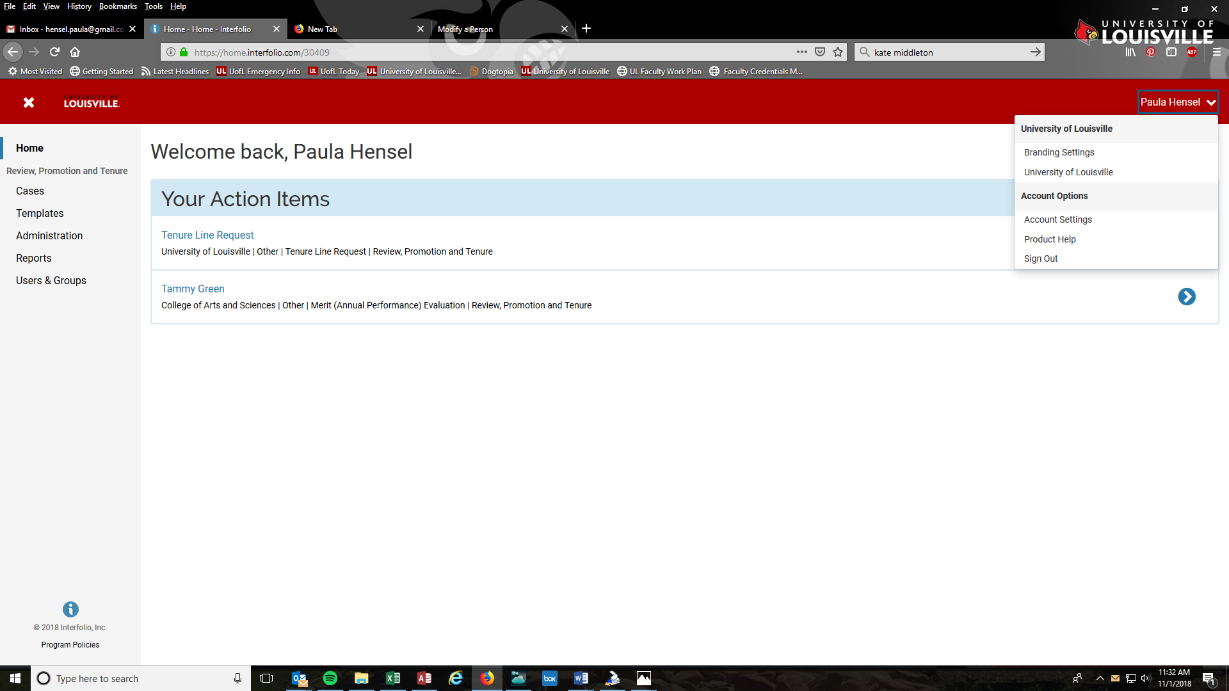

Click on “Help for Interfolio Review, Promotion, and Tenure”

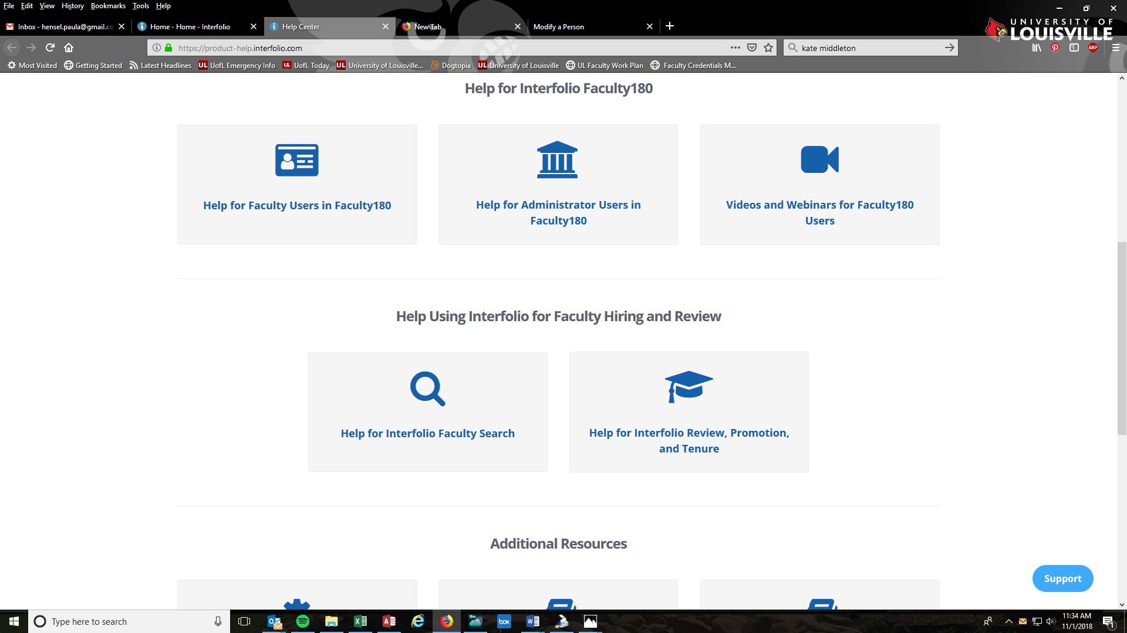

TO UPLOAD DOCUMENTS FOR YOUR PROMOTION/TENURE CASE

You will receive an email that a review has been initiated for you. Click “View Case.”
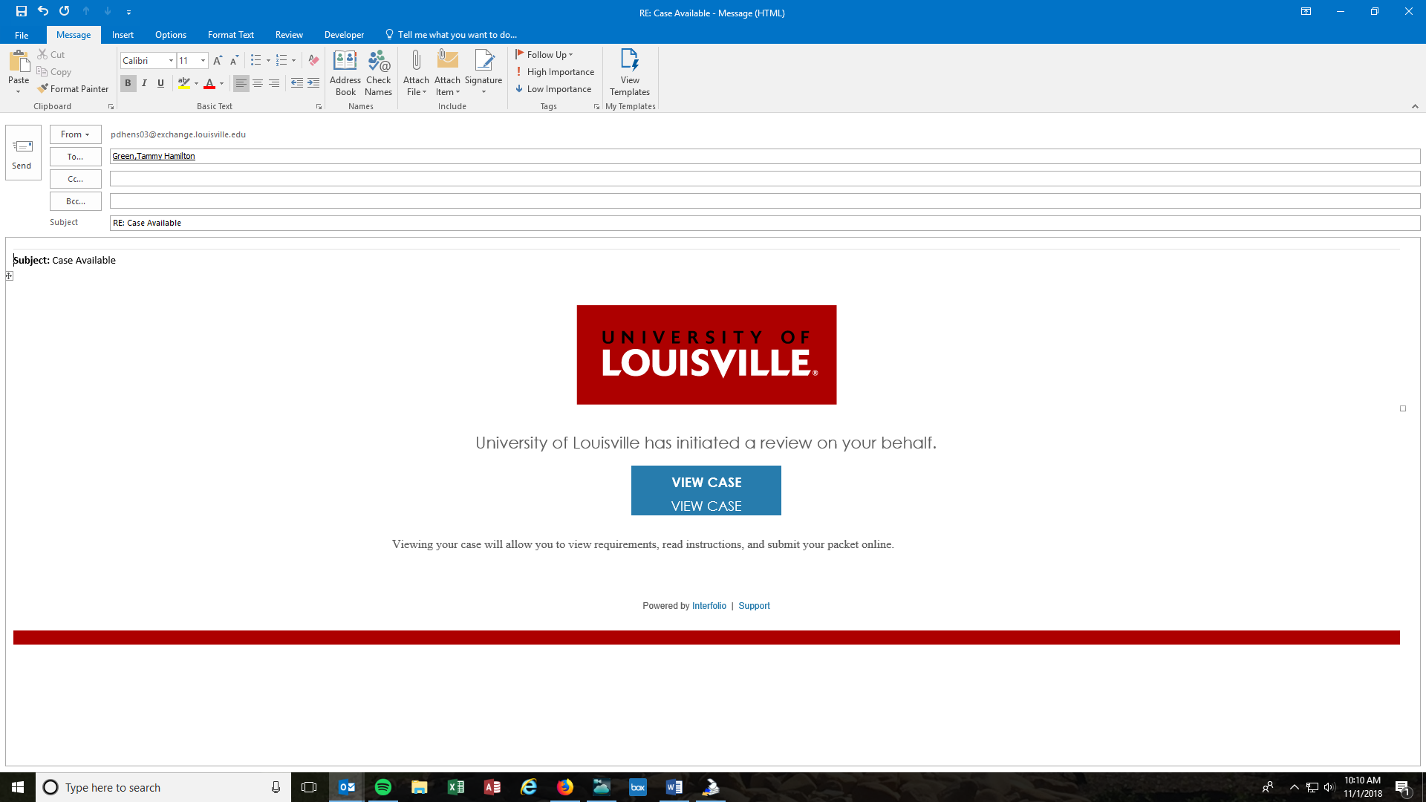

Sign in using your University of Louisville user name and password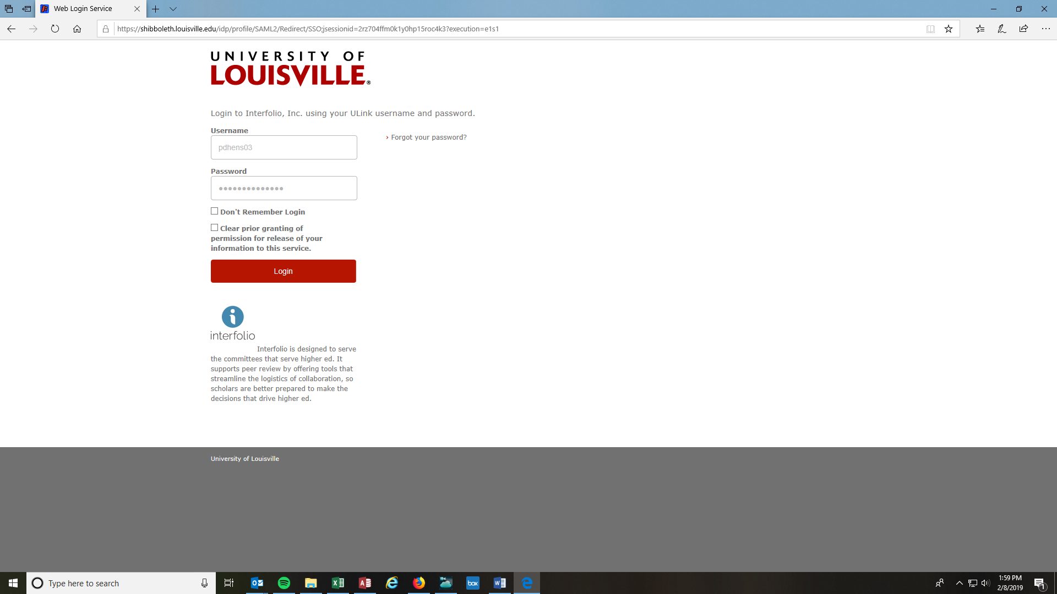

Click “Louisville”

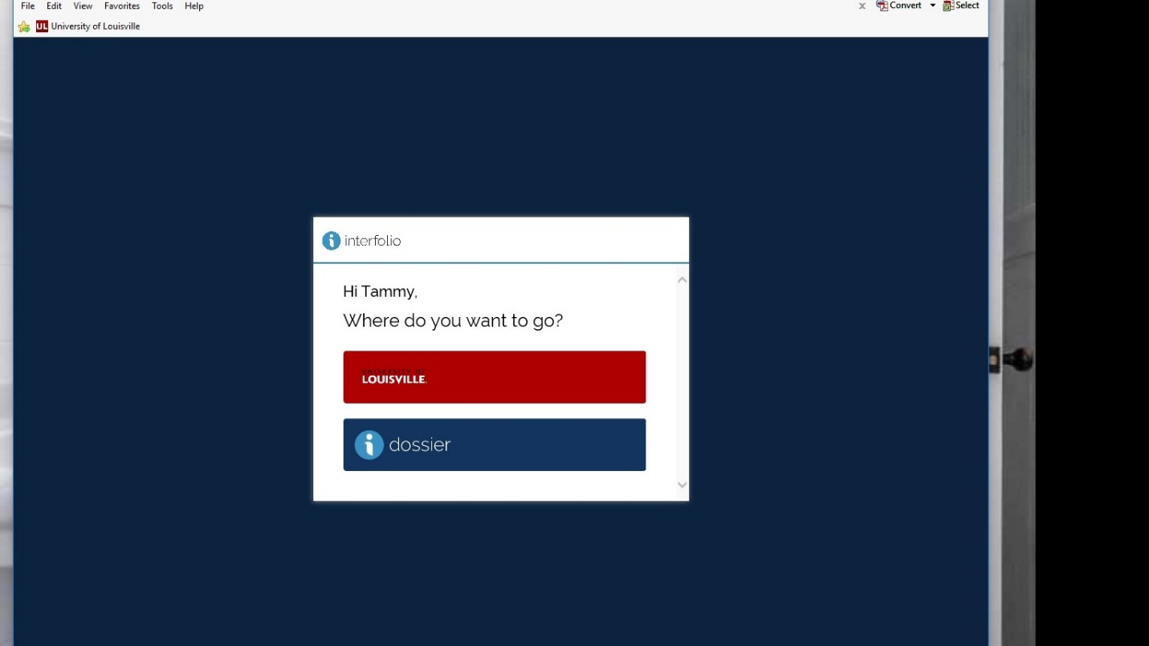

Click on “Your Packets” then click on the link under Active

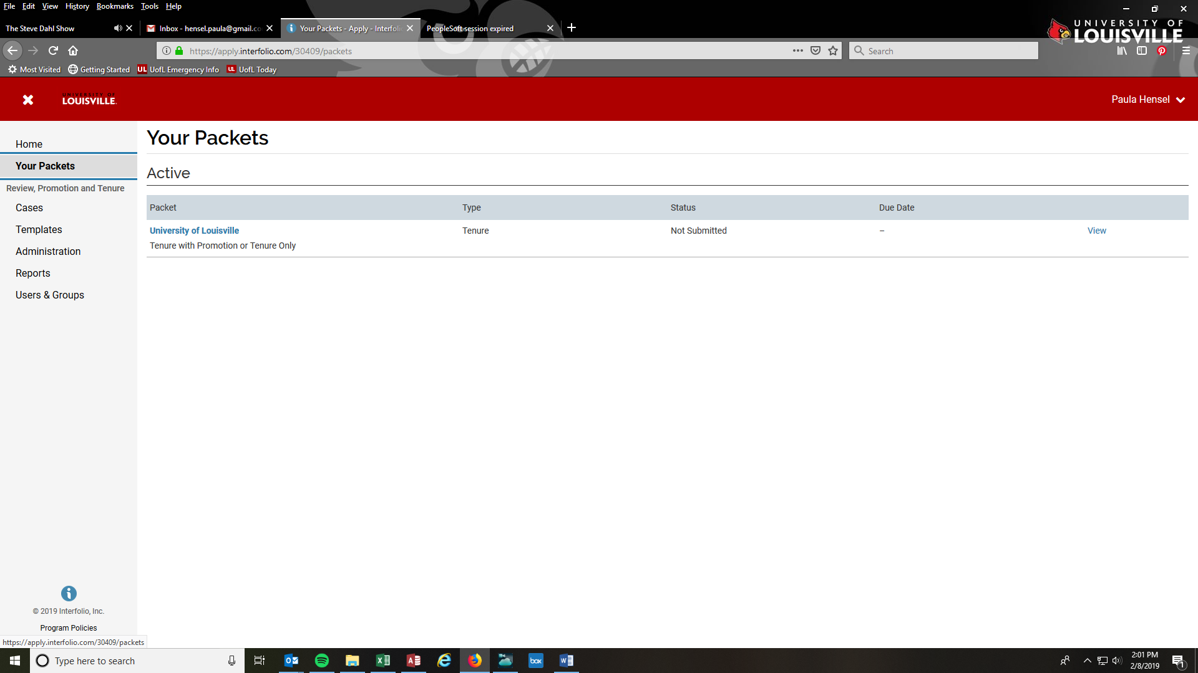

Overview will show a list of mandatory and optional documents to upload. Candidate Instructions will include instructions.
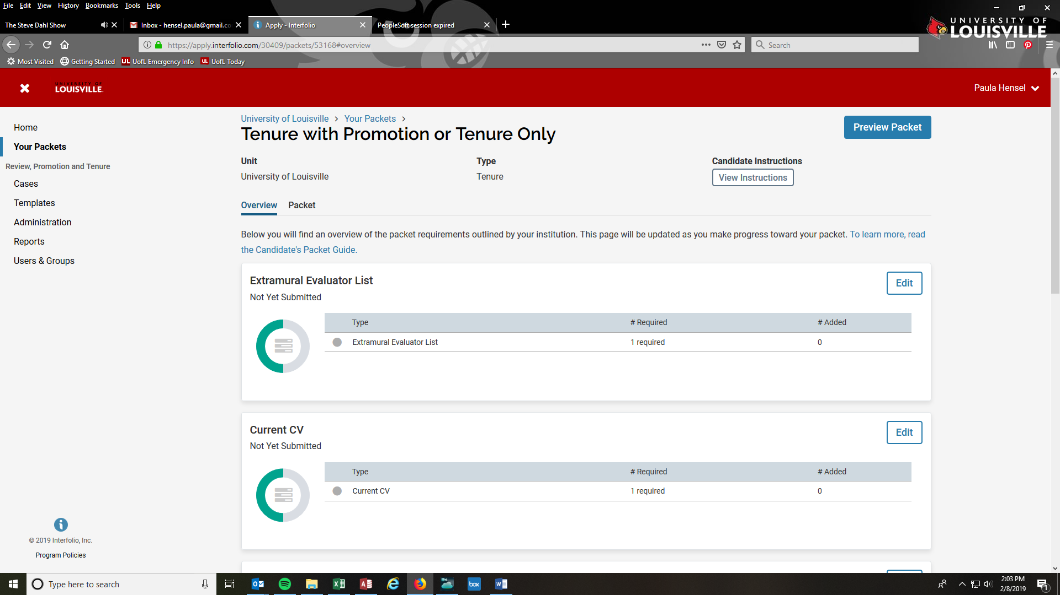

Click on “Packet” and upload requested documents by clicking the “Add” button.
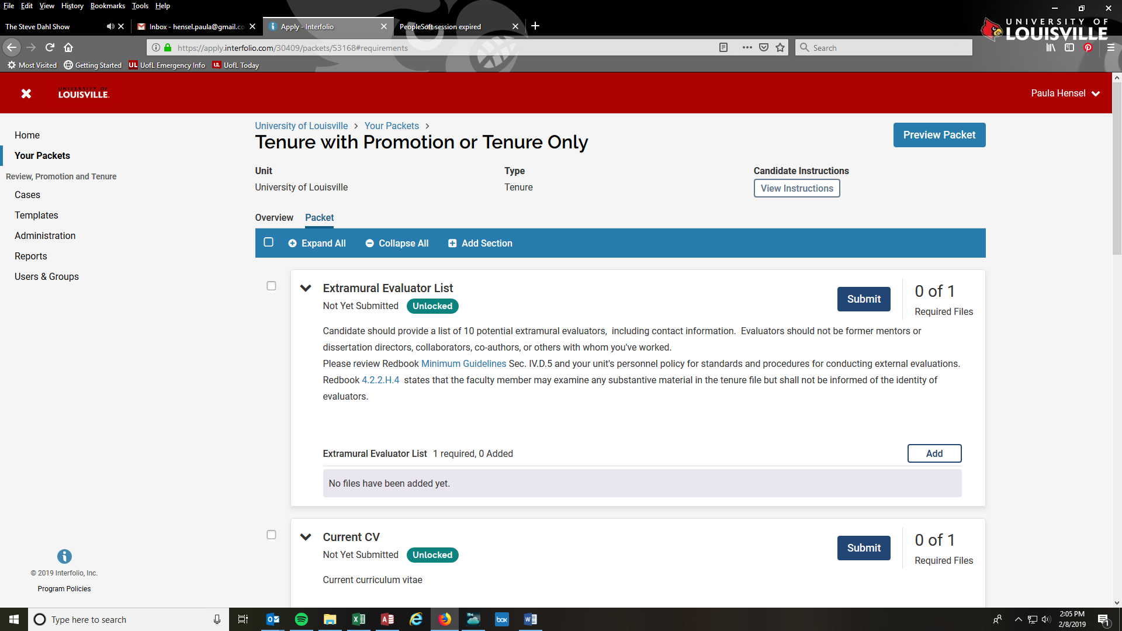

Click “Add New File” then click “Browse to Upload” to select the file you want to upload – after file is selected, click “Add”.
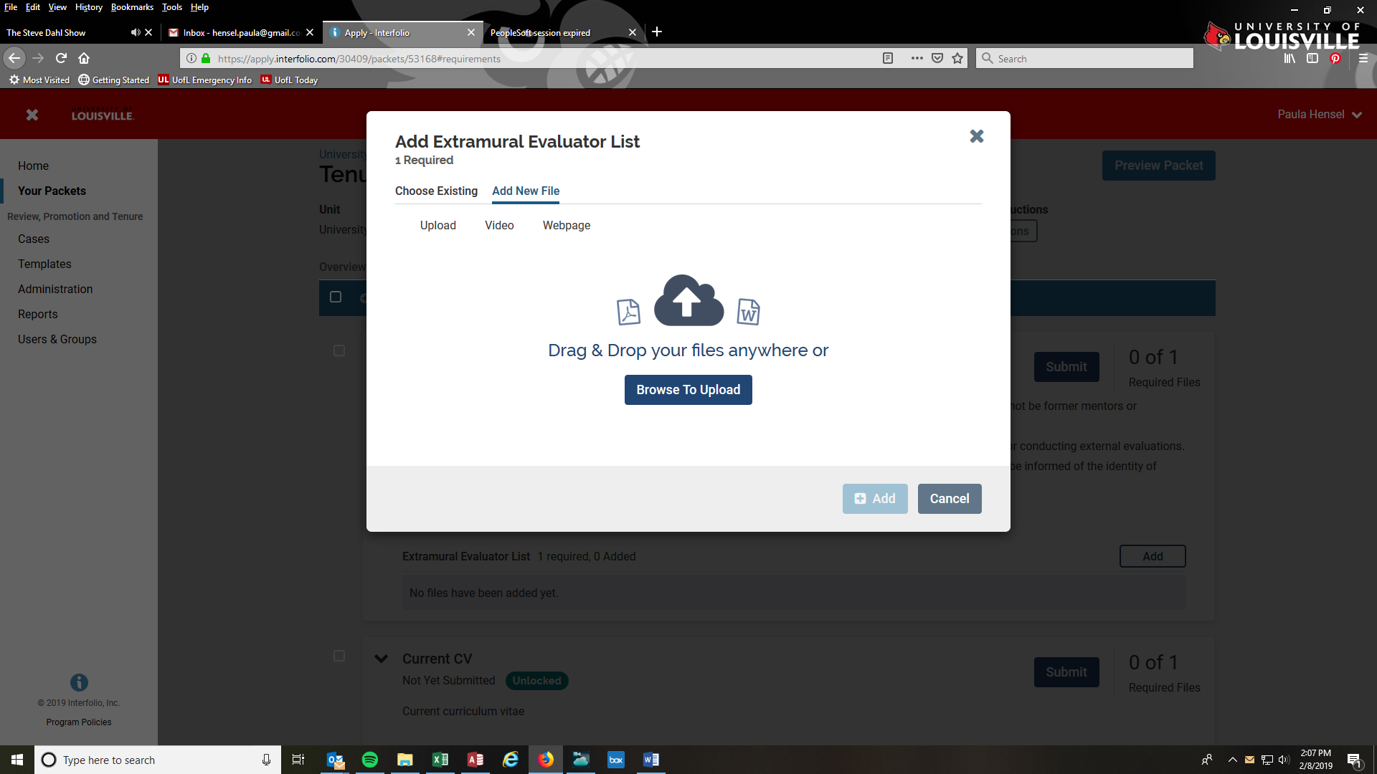

Follow the same procedure to upload any additional documentation. When all required and optional documents have been uploaded, click on “Preview Packet” to review your documents.
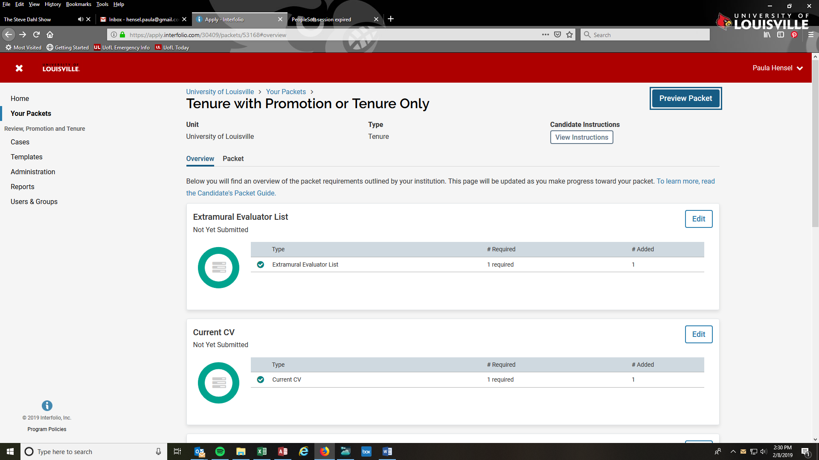

When all documents have been uploaded, while in the Packet tab, click “Submit” on each document.

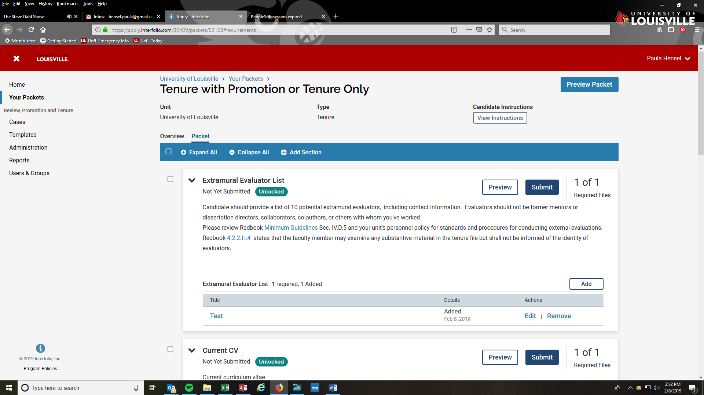

You can log into Interfolio at any time at www.Interfolio.com

Type “Louisville” where is asks you to search for your institution. Click on University of Louisville, then click on “Sign In”.

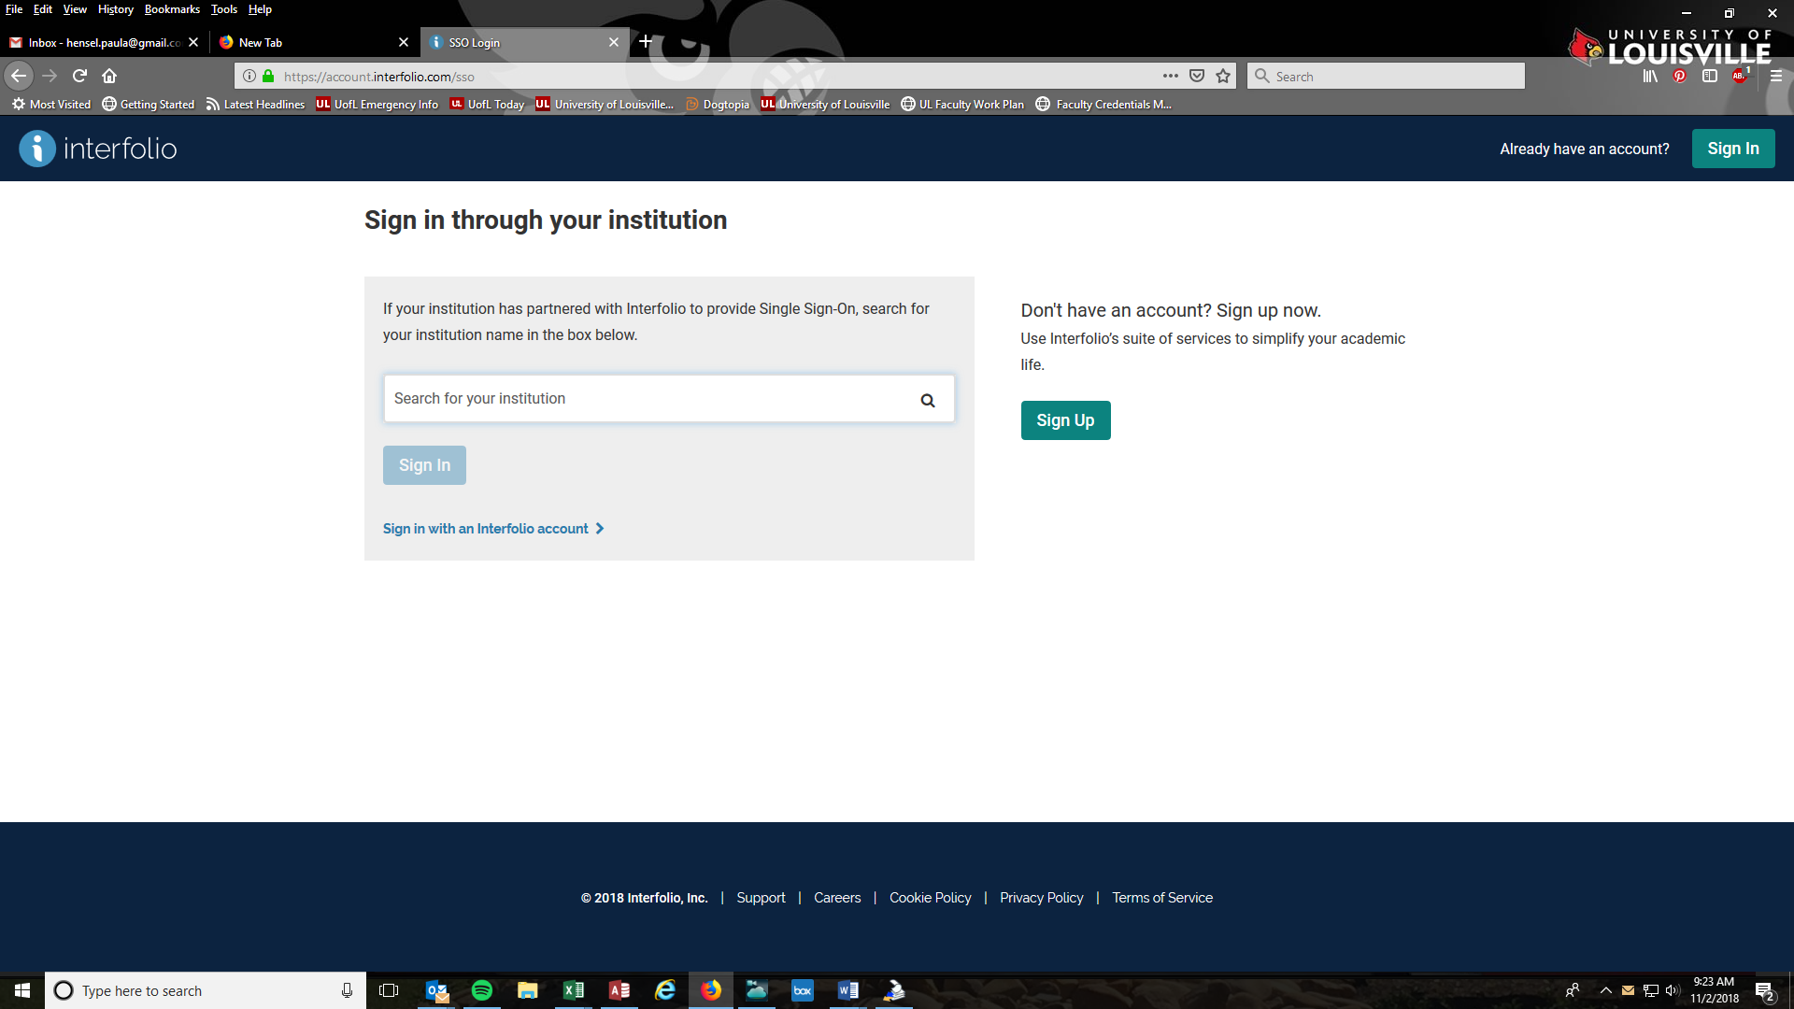

Use the same user name and password you use to sign in to your University of Louisville computer accounts

