  Organizing Committee:  Michael H. Nantz, Ph.D.  Teresa Fan, Ph.D.  K. Grant Taylor, Ph.D.  James L. Wittliff, Ph. D.  www.imd3.org | IMD³ Fall Fest
 | Harvesting Scientific Research  at the University of Louisville  
You’d scarce expect one of my age
To speak in public on the stage;  And if I chance to fall below  Demosthenes or Cicero,  Don’t view me with a critic’s eye,  But pass my imperfections by.  Large streams from little fountains flow,  Tall oaks from little acorns grow.  David Everett (1769 – 1813) | Friday, November 30, 2007  9:00 AM – 1:15 PM  The University Club, Ballroom B  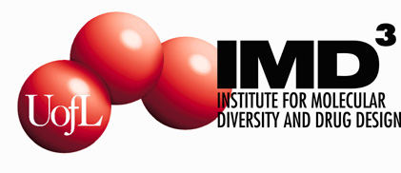

Schedule of Events:
8:45 AM | Registration & Coffee  Slide Set Up | 10:45 – 11:05 AM | Thomas M. Sabo  Analysis of GpIbα (269-286) Peptide Interactions with Thrombin’s Anion Binding Exosite II  Department of Chemistry  Mentor: Muriel C. Maurer, Ph.D.
9:00 – 9:15 AM | Introductory Remarks - Organizing Committee  Michael H. Nantz, Ph.D. & Teresa Fan, Ph.D.  Presentation of 2007 IMD3 Research Fellows  Enid Choi (Paula Bates, Mentor)  Bo Xu (G. B. Hammond, Mentor) | 11:05 – 11:25 AM | Sarah A. Andres  Validation of Gene Expression in Human Breast Cancer Using Quantitative PCR  Department of Biochemistry & Molecular Biology  Mentor: James L. Wittliff, Ph.D., M.D. hc
 | Oral Presentations by IMD³ Scholars  Travel Award Recipients | 11:25 – 11:45 AM | Pamela S. Steele, Ph.D.  Analysis of Nucleic Acid-protein Interactions Using Competitive Binding and Mass Spectrometry  Department of Pathology & Laboratory Medicine  Mentor: Saeed A. Jortani, Ph.D.
9:15 – 9:35 AM | Traci L. Kruer  Expression of Novel ERE-binding Proteins in Human Breast & Uterine Cells  Department of Biochemistry & Molecular Biology  Mentor: James L. Wittliff, Ph.D., M.D. hc | 11:45 – 12:05 AM | Yun Teng  Proteomic Studies of Nucleolin Complexes in Prostate Cancer Cells Treated with Novel Anticancer Agent, AS1411  Department of Medicine - Oncology  Mentor: Paula J. Bates, Ph.D.
9:35 – 9:55 AM | Satoru Arimitsu  Catalytic Preparation of Fluorinated Heterocylic Compounds  Department of Chemistry  Mentor: Gerald B. Hammond, Ph.D. | 12:05 PM – 12:15 PM | Closing Remarks  K. Grant Taylor, Ph.D. &  James L. Wittliff, Ph.D.
9:55 – 10:15 AM | Marjorie Bon Homme  Gene Expression Analysis of a Mouse Model  Department of Pathology & Laboratory Medicine  Mentor: Mark W. Linder, Ph.D. | 12:15 – 1:15 PM | Lunch & Table Discussion Groups
10:15 – 10:45 AM | Coffee Break

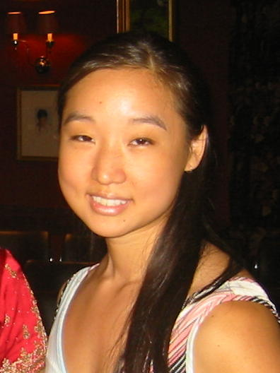
Enid Choi, 2007 Arno Spatola Graduate Fellowship Recipient
Enid received a B.S. degree in Chemical Engineering from M.I.T. in 2002, and then worked at the Massachusetts General Hospital of Harvard University. In 2004, she was admitted to the M.D./Ph.D. Program at the University of Louisville, where she joined the Department of Biochemistry & Molecular Biology. Her Ph.D. dissertation research, entitled Novel Tumor-Targeting Aptamers for the Treatment of Prostate Cancer, is directed by Dr. Paula Bates.

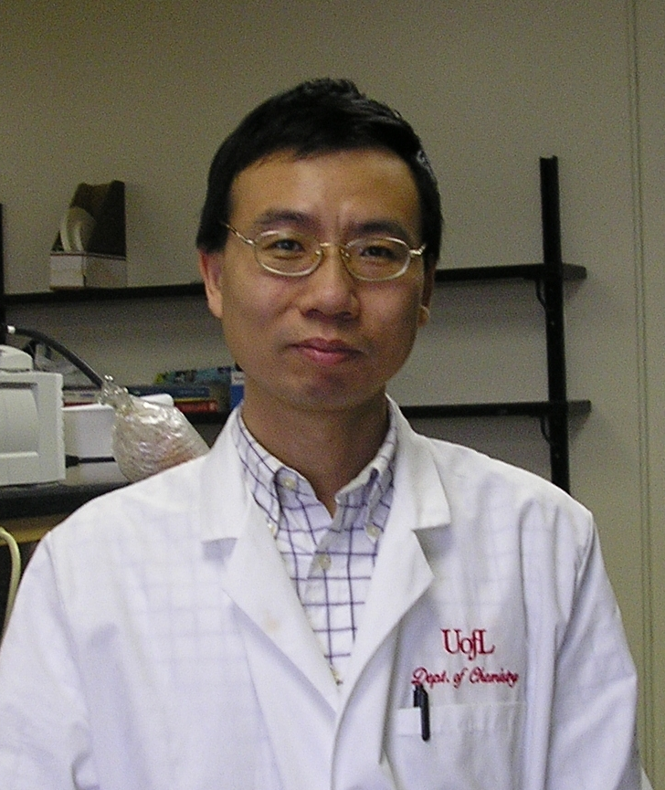
Bo Xu, 2007 IMD3 Graduate Fellowship Recipient
Bo began his training graduating from the East China University of Science and Technology in Shanghai, and then worked at the widely-regarded Shanghai Institute of Organic Chemistry. In 2003, he was awarded a graduate fellowship at the University of Massachusetts, Dartmouth, where he joined the research group of Dr. G.B. Hammond. Bo moved to the University of Louisville with Dr. Hammond to pursue his Ph.D. dissertation research entitled, Thermodynamically Controlled Aldol Reaction: the Effect of Cation Counterion on the Retroaldol Reaction.

Abstracts of IMD3 Travel Awardees

