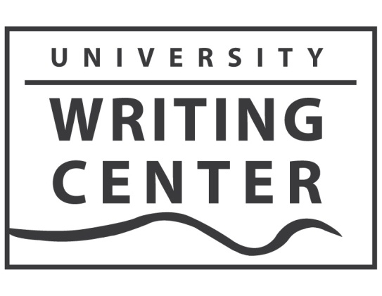

August 14, 2017

To: Glynis Ridley, Chair
Department of English

From: Bronwyn T. Williams,
Director, University Writing Center

Re: Writing Center Report AY 2016-2017

The University Writing Center had a successful year in 2016-17, marked by record-setting numbers of appointments in fall and spring semesters. Credit for the accomplishments in the Writing Center is shared by the director, Associate Director Cassandra Book, Program Assistant Robin Blackett, Assistant Directors Amy Nichols, Layne Gordon, Jessica Newman, and Chris Scheidler, as well as the dedicated and talented staff of consultants.

Achievements

1. Writing Center Consultations: The Writing Center had a successful year of consultations.
Visits for the 2015-16 Academic Year in Brief:

Fall 2016 – Belknap 2316 Visits
Health Sciences 42 Visits
Virtual 378 Visits
Total 2736 Visits (+235 over Fall 2015)

Spring 2017 – Belknap 2034 Visits
Health Sciences 40 Visits
Virtual 436 Visits
Total 2509 Visits (+ 214 over Spring 2016)

Summer 2017 – Belknap 277 Visits
Health Sciences 9 Visits
Virtual 90Visits
Total 376 Visits

Total for 2016-17 5259 Visits (+362 over 2015-16)

Our summer numbers were down slightly, but budget constraints meant we offered fewer hours in Summer 2017.

2. Exit Survey Results: Our exit survey indicated a high level of satisfaction with the Writing Center, by both quantitative and qualitative measures. Highlights of the survey are:

- In answer to the statement: “My Writing Center consultation addressed my concerns about my writing project,” more than 97% of respondents selected “Strongly Agree” (85%) or “Agree” (12%).

- In answer to the statement: “What I learned during my Writing Center consultation will help me with future writing projects,” more than 95% of respondents selected “Strongly Agree” (78%) or “Agree” (17%).

- In answer to the statement: “I plan to use the Writing Center again,” more than 95% of respondents selected “Strongly Agree” (82%) or “Agree” (13%).

- In answer to the statement: “The Writing Center staff were welcoming and helpful,” more than 97% of respondents selected “Strongly Agree” (87%) or “Agree” (10%).

The qualitative responses on the survey were overwhelmingly positive as well. A small group of suggestions requested longer consulting sessions. We feel the length of sessions is currently the most conducive to effective tutoring.

3. Presentations and Workshops: During the academic year, University Writing Center staff conducted 54 in-class workshops on writing issues, serving more than 1,200 students and 113 presentations about our services. Both of these were substantial increases over 2015-16. We also conducted workshops about effective writing for Residence Life, TRIO, the Cultural Center, SIGS, and other campus organizations.

4. Community Literacy Projects: We continued to provide tutoring and workshops at Family Scholar House. We began a partnership of tutoring and workshops with the Western Branch of the Louisville Public Library, including a highly successful series of comics-writing workshops over the summer.

5. Events: We sponsored or participated in nine writing-focused events including The National Day on Writing, the White Squirrel Literary Magazine launch, Kick Back in the Stacks, Banned Books Week, a Halloween Open Mic Night, International Mother Language Day, and the Celebration of Student Writing.

6. Writing Groups: We continued to facilitate the Graduate Student Writing Group; Creative Writing Group; and LGBTQ Writing Group.

7. Dissertation Writing Retreat: The spring Dissertation Writing Retreat during May was again a success. In the May retreat, funded by SIGS, 14 Ph.D. students representing five different colleges and nine different disciplines spent a week in the Writing Center working on their dissertations. The exit surveys and discussions with the students indicated that the retreat was overwhelmingly successful. We had eight students on our waitlist for the retreat.

8. Graduate Student Writing Workshop Series: The Writing Center, in collaboration with SIGS, conducted a series of writing workshops for graduate students on both the Belknap and Health Sciences Campuses. The workshops, some of which were repeated each semester, covered issues including Reading and Responding to Graduate Level Scholarship, Writing for Publication, and Writing a Literature Review. The workshops will take place again in 2016-17.

9. Writing Center Blog and Social Media: The Writing Center Blog, to which all members of the staff contribute posts during the year, was viewed more than 12,000 times in 2016-17. In addition, many of the posts have drawn interest from readers outside the UofL community.

10. Writing Center Scholarship: During the 2016-17 academic year University Writing Center staff (not including the director) had six scholarly and creative publications. In addition, Cassandra Book, the associate director, received a grant from the Southeastern Writing Centers Association to conduct a usability study on our Virtual Writing Center. Writing Center staff also had 16 conference presentations at conferences including the International Writing Centers Association Conference, the Conference on College Composition and Communication, the Southeast Writing Centers Conference, the Kentucky Philological Association Conference, and the National Conference on Peer Tutoring in Writing. had a chapter published in an edited collection on Writing Center research.

11. Learning Commons: The Writing Center continued to meet with other student support organizations located in Ekstrom Library to coordinate Learning Commons' activities. The offices involved are the Digital Media Suite, Media Resources, the REACH Computer Resource Center, the Reference & Information Literacy Department, and the Writing Center.

12. Student Artists on Display: We continued with our rotating display of student art.

13. New Website Resources. – We website information on Accessibility and Accommodation, revised and improved the layout of the Appointments page based on Cassandra Book’s usability study, and created new video workshops on writing issues such as Literature Reviews and Resume and CV Writing.

Plans for 2017-18

Axton Reading – Our ongoing collaboration with the Creative Writing Program will include hosting an Axton Series Reading in February 2017.

Community Literacy: We plan to expand our hours and programming with our community partners and our work with the new English 508 course.

New HSC Office: We have moved our office at HSC into a more central location that will be more convenient to students and other HSC related offices. We will use this opportunity to explore new collaborations with the HSC Research Office.

