lifeBOKS Program for Kids with Autism Who Wander

lifeBoks is a free kit provided to autistic children to prevent wandering and wandering related accidents.

Get a FREE lifeBOKS (just pay shipping) by downloading the KultureCity® App
Autism & Wandering

50% of autistic individuals wander or bolt from safety. This can put them at risk of trauma, injury or even death. 62% of families of these individuals were prevented from attending / enjoying activities outside the home due to fear of wandering thus decreasing their accessibility to the community.

lifeBOKS changes that. It breaks down the familial barriers and creates accessibility by providing families with the confidence to go out into the community without fear of wandering.

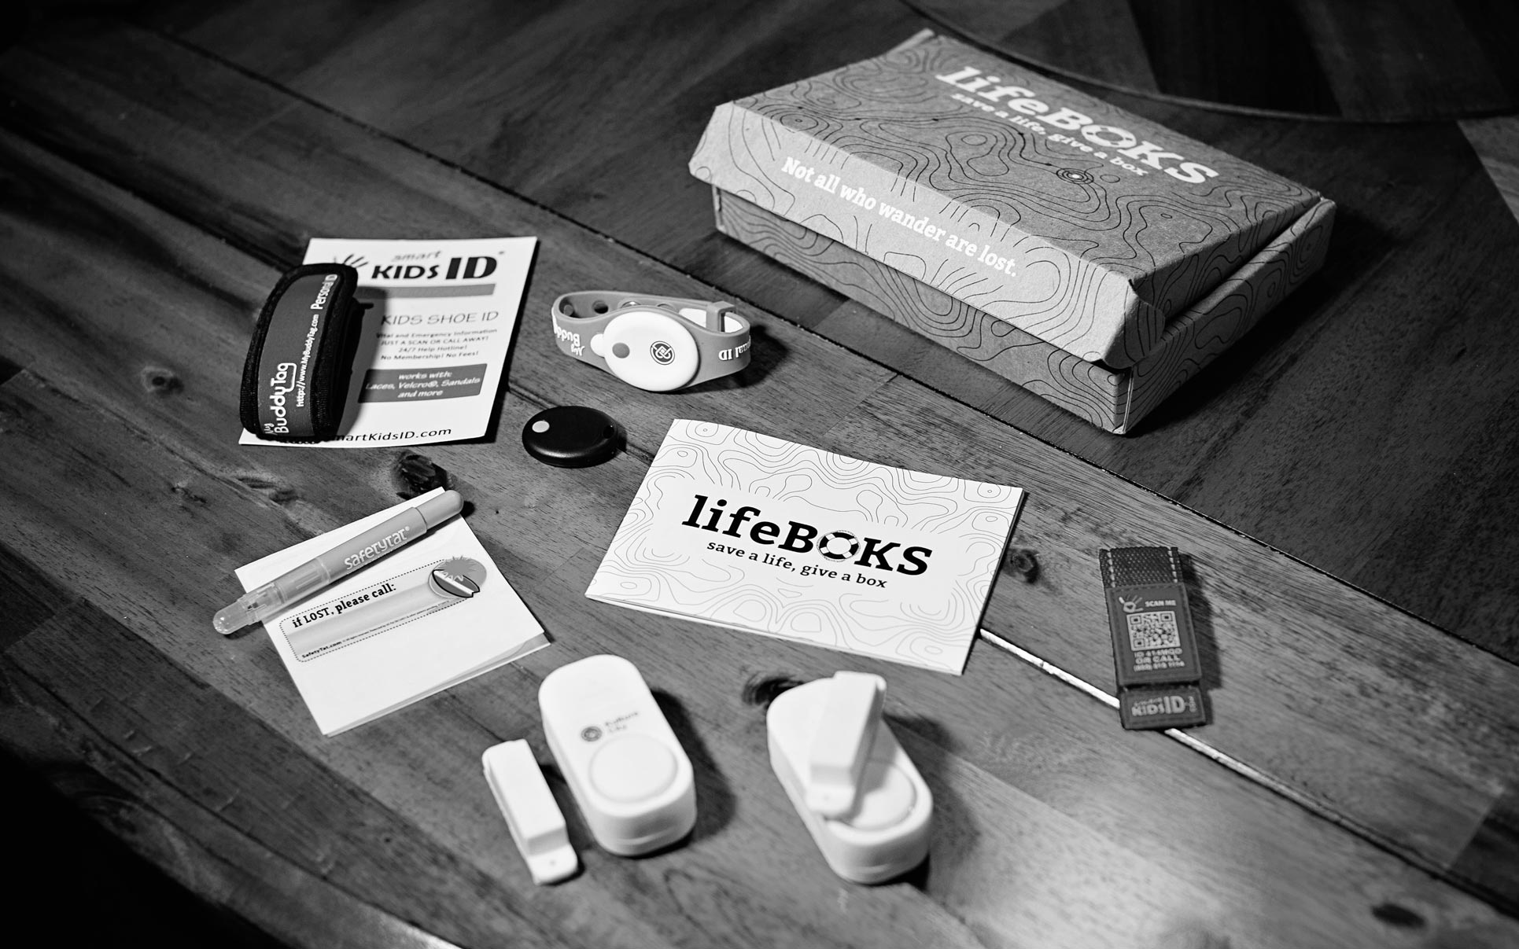
What’s in a lifeBOKS?

SafetyTat
These are temporary tattoos that provide an extra layer of identification in the event of a wandering.

Window / Door Alarms
These alarms provide a simple low cost effective solution to protect your loved one from wandering thanks to the 120 decibel alarms that sound when a door or window is opened where the alarm is placed.

SmartKids ID Shoe Tag
This shoe tag combines QR Code technology with a 24/7 toll free Help Hotline thus helping first responders identify your loved one in an event of an emergency.

Bluetooth buddy tag tracking bracelet
This is a Bluetooth device that has an out-of-range alert to help prevent losing your child; a water safety alert to help prevent accidental drowning and a panic alarm for your child to alert you when in a threatening situation. It has no monthly fee and requires no charging.

