Safety Resources

Yellow Dot  The Yellow Dot Program alerts first responders at crash scenes of critical medical information that could save a life. Participants in the program provide important medical information that could help emergency responders make split second decisions by placing the Yellow Dot decal in the lower-left corner on the driver-side rear window and the completed Yellow Dot personal information folder into the glove compartment of the vehicle. Yellow dot stickers and information folders can be requested online at: http://bit.ly/YELLOWDOT | 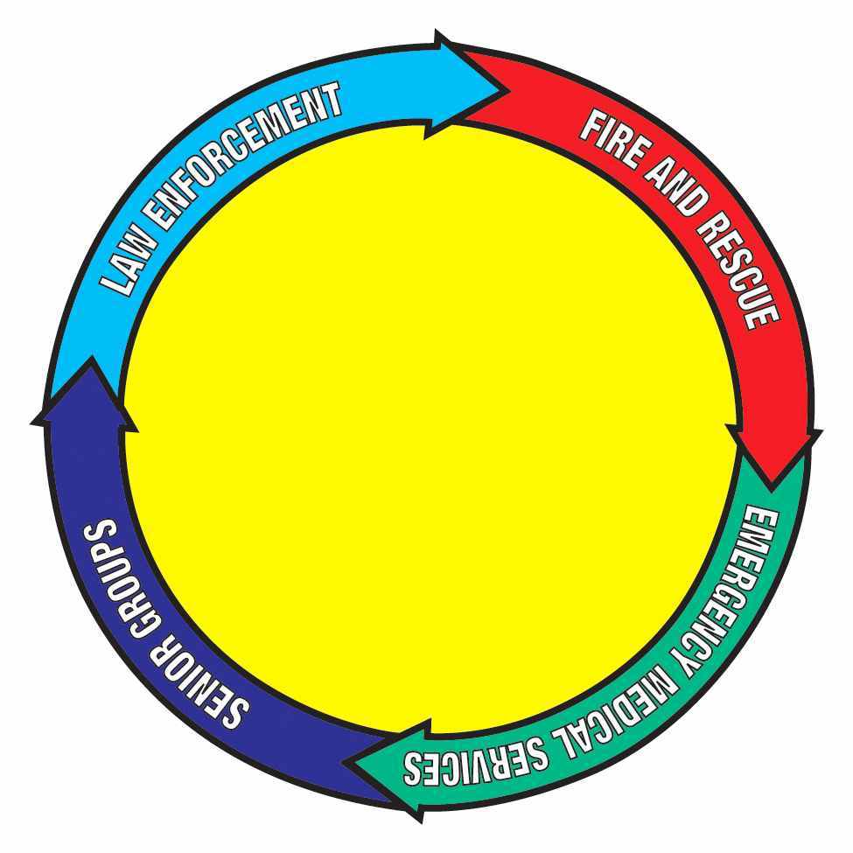
Smart 911  In an emergency, seconds count. Now you can save seconds with Smart911, a free service provided by your community. Sign up today to provide information to 9-1-1 and first responders before an emergency happens, so they can better help you during one. Accounts can be created online at: https://smart911.com/ | 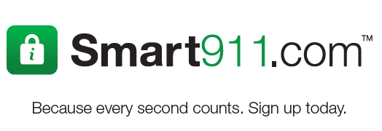
MedicAlert
MedicAlert Foundation operates under the mission “protect and save lives”; therefore, we developed the new MedicAlert Found® program to provide an additional layer of protection for the autism community. Our goal is to ensure every person affected by autism has our autism medical IDs and 24/7 wandering service. Join us in our effort to reduce the number of wandering tragedies by enrolling your loved one today. For more information, visit: https://www.medicalert.org/autism

Additional Resources: bit.ly/KATCsafety  Request a free training for First Responders  First Responder Awareness Brochures  Autistic Self Advocacy Network’s Autism & Safety Toolkit  National Autism Association’s Big Red Safety Box  Autism Speaks’ Safety Project | (502) 852-4631

