Teaching Communication Across the Day

Laura Ferguson, M.Ed., BCBA

Participant Outcomes

• Overview of Communication strategies

• Ideas on ways to teach communication

“Qualitative impairment in COMMUNICATION,
manifested by at least one of the following”:

• Delay in or total lack of spoken language.

• Impairment in ability to initiate or sustain conversation.

• Stereotyped use of language.

• Lack of make-believe play

Communication and Autism

• Deficits in nonverbal communication is one of the earliest signs of the disorder

• Deficits in vocal communication often the first symptom noted by others

Communication and Autism

• Importance of communication as a foundation for the development of social, play, academic behaviors, etc.

• Importance of appropriate communication to replace or prevent the development of inappropriate communicative behaviors such as tantrums, SIB, aggression

Modes of communication

Topography Based

• Involves producing a unique response FORM for each word

• Examples:

– Vocalizations

– Sign language

Modes of communication
Selection Based
• Involves scanning an array of pictures, words or symbols and selecting one via point/touch
• Examples:
– PECS
– Dynavox
– Go Talker
– Intellikeys
– Switches

REMEMBER: It is fine to instruct multiple modes for various situations (expressive/receptive)

Reinforcement

A stimulus change immediately follows a response and increases the future frequency of that type of behavior in similar conditions.

Communication

It is important that the communication we teach is:

Motivating Functional Meaningful
Based on Student Preferences- See Handout

Motivation

• If the words, signs, or pictures we attempt to teach are not motivating to the child it will be difficult for them to acquire the word.

• If we don’t give them enough to say then they may result to utilizing behavior to gain what they need/want.

Mand

• Type of verbal operant in which a speaker asks (or states, demands, inquires, etc.) what he needs or wants.

• Example: asking for a shoe when you want a shoe.

• Asking for a gummy bear when you want a gummy
bear

• Asking someone to stop tickling you when you want them to stop tickling

Mand Training

• Mands are the first verbal operant acquired by
by a human child.

• They usually occur in the form of crying when
a child is hungry, tired, in pain, cold, wants toy,
afraid, etc.

• Typically developing children quickly learn to
replace crying

(Cooper and Heron, 2007)

Mand Training
• Manding not only lets children control the delivery of reinforcers, but it begins to establish the speaker and listener roles that are essential for further verbal development.

• Manding is the only type of verbal behavior that benefits the speaker.

• Meaning the mand gets the speaker reinforcers.

(Cooper and Heron, 2007)

Mand Training

• It is important that mand training occurs throughout the day for individuals on the autism spectrum.

• This will include contriving situations and providing opportunities for these mands to occur.

Contriving Manding Opportunities

• For example, Mickey loves vacuums and everyday after school he rushes to the hall closet to look at the vacuum.

• To contrive a mand for the vacuum you place the vacuum in another location. When he arrives prompt the mand for vacuum.

Contriving Manding Opportunities

• Sally always comes into the playroom to grab the ball out of the toy box. You place the ball on the top shelf where Sally cannot reach it.

• You have now contrived the opportunity for multiple mand responses.

Examples; help, ball, where is it, which shelf,etc.

“Choice boards empower children
to participate actively in their
home, school, and community
environments.” (Savner, 1999)

Implementing a Choice Board

What are the skill
prerequisites?

Steps for Implementing a Choice Board

1. Select an opportunity during the day when a student has choices

2. Create visual representations of the available choices using actual objects, drawings, photos, or icons

3. Present these visuals to the student and allow time for her/him to point to or pick up the desired object
✓ Only present options that are available at that time

4. Acknowledge the student’s choice by verbally labeling the choice
(“You chose blocks”)

5. Give the student the chosen item or allow her/him to get the item for herself/himself (James & Knowlton, 2007)

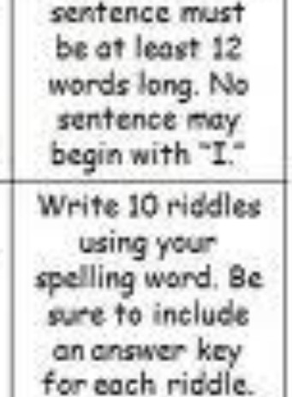Choice Board

Wr4teyo r
spellrng
wor s three
·meseach
ree Choice!
Yo decide
how to
practice.
tc 12
ftt:tcnees tach

wa t

. in cursive.-J.. your word$.

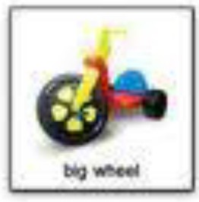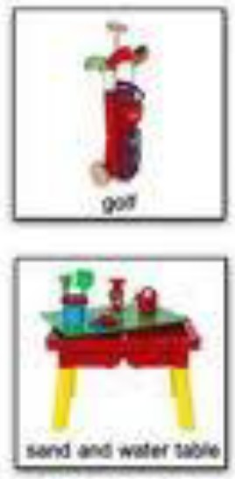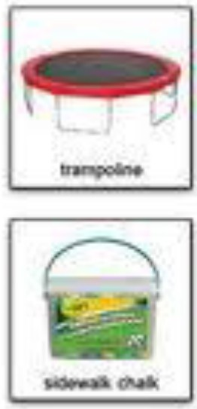Write oil your words tnA8C
Ord tn
cursiv .

'Nit c
c ivestcry
"''"9 5 of your
lling words
sorr.ewhtr"<!: i
your Qry.
u,-!l9Q nc:.50urus f i r:a sy Off $ 0"'
orrtor: rr. for10
of yr spelling
wo
'Nr e th
deft ni io for
12 ds (not
enrichment
wo )

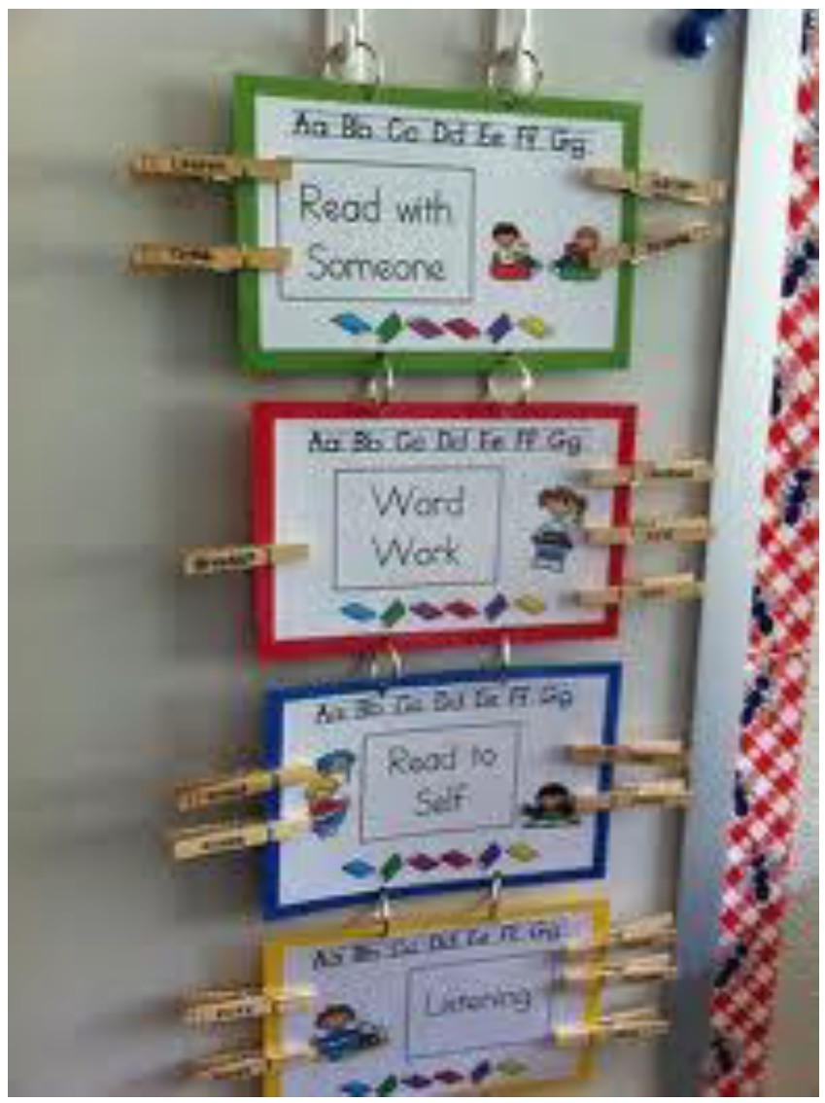

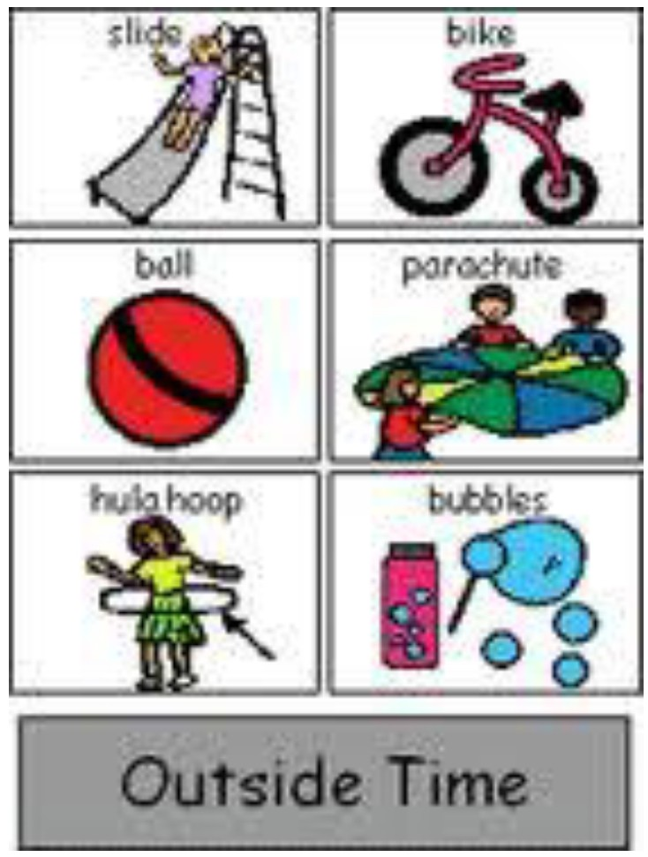

Functional Communication Training (FCT)

FCT is a systematic practice to replace
inappropriate behavior or subtle communicative
acts with more appropriate and effective
communicative behaviors.

When using FCT, teachers/practitioners analyze the problem behavior to determine what the
learner is trying to communicate.

Functional Communication Training (FCT)

Why do you think FCT is such a powerful intervention for students with ASD?

Functional Communication Training (FCT)

What types of things do students with ASD
communicate via problem behavior?
‘Hi, notice me” “I need help”
“ I don’t want that” “What is that”
“I want that one”
“Something’s wrong”

Functional Communication Training (FCT)

Reinforce the student saying help, instead of screaming when the computer freezes.

Reinforce handing a picture card to a peer
requesting a toy instead of grabbing it.

Functional Communication Training (FCT)
Advantages

Dramatic decrease in challenging behavior

• Increases communication
• Social validity
• Gains that generalize
• Gains that last
Disadvantages
• High rates of recruitment for reinforcement
• Request may occur at inconvenient times
• Extinction may produce undesirable effects

Functional Communication Training (FCT)

FORMS Function

Gestures Signs Words
Picture systems Requests/ Objects Mands Technology

Sign Language

Teaching sign language to children with autism can
serve the purpose of functionally replacing other
disruptive behaviors such as aggression

Teaching a child with autism to communicate using sign language may be an easier transition to vocal communication

Advantages of Sign Language

• May help to develop motor imitation

• Stimulus & response often resemble each other, providing a built in prompt
• Topography based, like speech
• Single stimulus and single response relation, like
speech
• Community of signers already exists
• Can be used to teach all operants

Disadvantages of Sign Language

• Parents & teachers must learn the child’s signs

• Parents & teachers need to use sign language when interacting with the child

• Parents & teachers must teach/shape each individual sign

Begin Sign Training by teaching
Mands

• Identify items and activities that are reinforcing for the learner

• Select reinforcers that instructors can easily control and that provide many opportunities to mand (request)

• Determine the manual sign for each of the reinforcers the child will learn to mand for

Selecting Mands

• Do NOT teach the following until the learner can mand for many items:
– Yes/no
– More
– Finished
– Please
– Potty
– Help
– Eat
– Drink
– Help
– Carrier phrases (“I want .” “Give me .”)

Why not teach these mands?

• These are generalized responses.

• If a child is signing “more” it will be difficult for the the listener to understand and reinforce their request.

Picture Exchange Communication
System (PECS)
• designed to teach functional communication with an
initial focus on spontaneity

• There are 6 phases

– How to communicate

– Distance and persistence

– Picture discrimination

– Sentence structure

– Answering questions

– Commenting

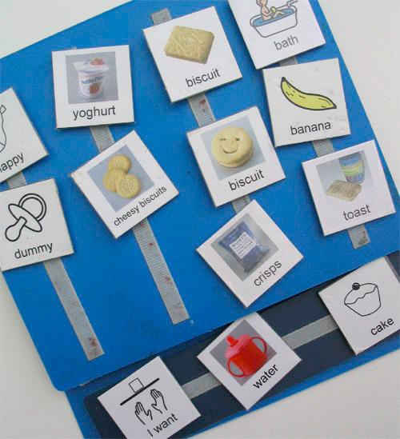Picture Exchange Communication
System (PECS)

Picture Exchange Communication
System (PECS)
• If PECS is chosen as the communication
system it is important that the book is
available throughout their day.

• Make sure it is available at home, school, on the bus, etc.

• This will increase use as well as initiation of communication

Advantages of PECS

Each exchange is clearly intentional and readily understood. When a child hands you a picture or sentence strip, the request or comment is quickly determined

Communication is initiated by the child

Communication is meaningful and highly motivating

Disadvantages of PECS

Parents and educators must be trained

After pictures and binders, it can get expensive

In order for a child to request something, there must be a picture. Therefore, there must be pictures of almost everything in their environment

Opportunities to Respond (OTR)

• The number of times the teacher provides academic requests that require students to actively respond

• A teacher behavior that prompts or solicits a student response - Results in positive behavioral and academic outcomes
• Allows teacher insight

– (Miller, 2009; Sprick, Knight, Reinke, & McKale, 2006)

Opportunities to Respond (OTR)

• Increases student engagement with instruction
• Allows for high rates of positive specific
feedback related to behavior

• Limits time for engaging in inappropriate behavior

• Results in more effective use of instructional time

Opportunities to Respond (OTR)

• Can be used as a quick assessment to guide teaching/lesson direction
• Provides teacher information on
student understanding/thought process

• Allows teacher to correct errors in knowledge/understanding
• Evidence of gains in Reading and Math
(e.g. mastery, rate, etc.)

OTR

Verbal Non-verbal

• Orally answering a question
• Sharing thoughts
• Summarizing
• Repeating
• Writing
• Performing an action
• Moving about room

Types of Verbal and Non-verbal

Verbal Non-verbal

Individual Question

Choral Responding
Response Cards/Response
Systems

Movement Activities

Peer Interaction

• Make sure that there are multiple opportunities to interact with peers

• Lunch time- have the student mand for items from peers and/or paraprofessionals

• Recess- place items that they need two people to complete the activity (i.e., bubbles, chase, catch)

• Free time- items that are reinforcing are in close proximity to peers. Reinforce student when they are within proximity of peers or are playing with peer

In Summary

One of the most important things we can teach individuals with autism is the ability to communicate.
•Choose a communication system(s)( or let
them choose)
•Be consistent

•Have the communication systems available all the time across environments
REMEMBER: It is fine to have more than one
FORM of communication.

Thank you so much for coming!!

Questions??

Questions?

Contact info: Laura Ferguson Laura.ferguson@louisville.edu

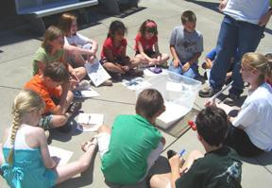Center contact info:

Telephone: (502) 852-4631
Fax: (502) 852-7148 E-mail: katc @ louisville.edu https://louisville.edu/education/kyautismtraining

