Meeting Sensory Needs

Kimberly Howard M.Ed.

Objectives:
• The participant will leave an understanding of
Sensory Processing Disorder.

• The participant will leave with an understanding of how this impacts children with autism.

• The participant will be exposed to different ways to meet the sensory needs of children with autism.

What is Sensory Processing or Sensory
Integration?

• We received messages from all of our senses and respond to this info

• Examples: Reading a book at home
– Not noticing noises going on around us
– Not being bothered by the feeling of the chair under us
– Not having to think about how to keep ourselves balanced

– Adjusting the temperature if we are cold, getting a blanket, etc.

LOUISVILLE Kentucky Autism Training Center
UNIVERSITY OF

RESPONSE SENSORY INPUT

A response is generated Sensory receptors are stimu ted.
PROCESSING
Sensory information is organised and interpreted, stored a nd rellated to
. .
prev1ous expenences.

UNIVERSITY OF
LOUISVILLE.
KENTUCKY AUTISM .
TRAINING CENTER

Sensory Processing Disorder (SPD)

• This means that there are difficulties with processing sensory input which affects functioning in day to day life
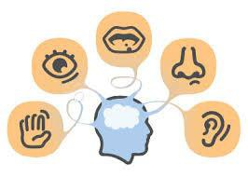

Types of Sensory Needs

Hyper-sensory Hypo-sensory

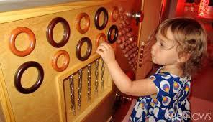

Hyper-Sensory Red Flags

• Poor Balance Coordination

• May notice sounds that no one else if picking up on

• Fearful of surprise hugs or touches

• May avoid messy play

• Fearful of Playground equipment

• May become very upset at diaper change time or when diaper needs changed

Hypo-Sensory Red Flags

• Thrill Seeker

• High Pain Tolerance

• Doesn't understand personal space

• May be very fidgety & unable to sit still for long

• May mouth objects excessively

• Seeks out messy play

LOUISVILLE Kentucky Autism Training Center
UNIVERSITY OF

DO YOU KNOW ME?
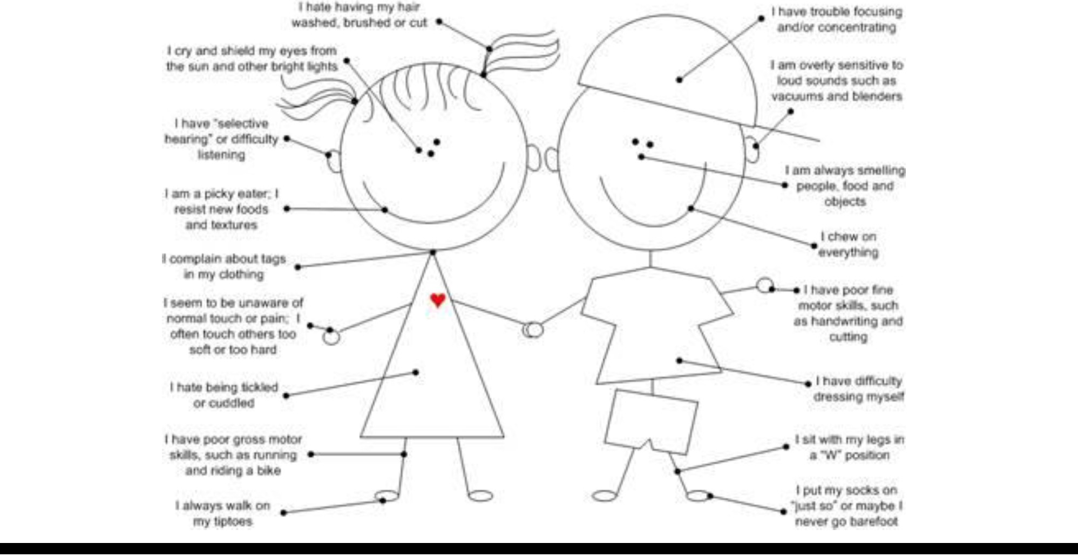

UNIVERSITY OF
LOUISVILLE.
KENTUCKY AUTISM .
TRAINING CENTER

Where do I go From
Here?

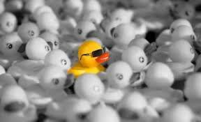

Every child is Unique.

What works for one child may not work for another.

• What makes you feel calm after a hard
day?

• How do you wake yourself up during
the day?

• What makes you feel disorganized or frazzled?

Environmental Considerations

• Considering the environment is often VERY helpful.
We can possibly make some changes that will help the child a lot with staying calm. Things to consider:

– Lighting: fluorescent lighting is “annoying” to the
body, especially if there is also flickering!

• Dim the lights, use flame resistant light covers to deflect lights, get rid of fluorescent lights, provide lamps as lighting, use natural light

– Environmental Cont.

– Visual distractions: lots of stuff on the walls, on shelves, etc. is actually telling the body to pay attention and register all the stuff.

• Try covering bookshelves with a solid sheet to limit distractions, clean up clutter if possible, organize things into special bins for intended purpose: that way you can take out limited things at a time and teach child to clean up before taking out another bin.

• Painting rooms “cool” colors such as blue or green. (Bright colors can be alerting)

Environment Cont.
Noise: Lots of noise in your home, community, etc.
We are multi-taskers by nature!
• Turn off the TV/music, etc.

• Try soothing sounds like a table fountain, methodical ticking sound, a rain stick, nature sounds CD, etc.
• Try out regulating music with regulating beat

• Try out noise cancelling headphones, an ipod with favorite music, or earphones

When do we need calming?

Your child had so much fun at the park, swinging for half an hour, going down the slide and spinning on the merry go round. It’s time to go and your child has a HUGE meltdown and can’t calm down. You find them hard to calm
for the next couple of hours. What to do?

Calming Activities

• Breathing is one of the “power regulators” and helps our body get back to a calm state > for example during yoga for relaxation

• Breathing is important in our ability to pay attention
because oxygen is delivered to our brain.

• A lot of children do not breathe deeply enough to get a lot of oxygen (possibly due to posture, anxiety, etc.)

Some breathing activity ideas:

– Playing games with straws such as blowing feathers, pom poms, and ping pong balls. *Cutting the straws in half may make it easier for your child to blow and point at a target.
– Using straws to blow ping pong balls or other items
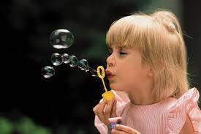in the bath
– Blow Bubbles
– Blowing pinwheels

• The Mouth is a power regulator too! This is why we see kids like bottles and soothers and chewing/sucking on things

• Sucking input gives strong deep pressure input to the mouth and brain

• Sucking Activities:

– Using short straws to eat snacks such as pudding, yogurt, apple sauce, etc.

– Sucking/chewing on special “chewalery” or special
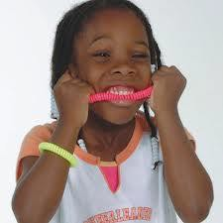pendant around the neck

– Sucking on a piece of rubber tubing

– Sucking on a piece of fruit before eating it

• Deep pressure massage is often very calming. Also special program with a surgical brush

• Weighted items provide this deep pressure: blankets, lap pads, vests, snakes, etc.
• Creating a “womb like” space to retreat to is often
helpful
• Slow linear rocking in a rocking chair
• Lowering your voice

• Using a drum or a metranome with rhythm may help with calming

LOUISVILLE Kentucky Autism Training Center
UNIVERSITY OF

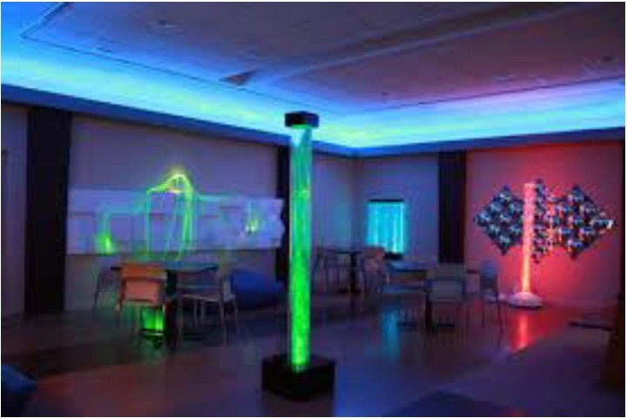UNIVERSITY OF
LOUISVILLE.
KENTUCKY AUTISM .
TRAINING CENTER

Heavy Work Activities

• Pushing wheelbarrow

• Hanging from monkey bars

• Crawling on hands & knees

• Pushing against an immovable object.

A Sensory Diet

• A sensory diet consists of regularly planned sensory based activities within the context of natural activities or routines.
• Aims to keep your child regulated/ organized
throughout the day.

• Created usually with the help of an occupational therapist trained in Sensory Integration therapy.
• Created based on the sensory profile you filled out,
based on the child’s needs.

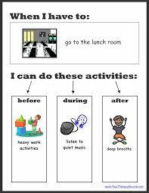

Sensory Diet

Sensory Diet

•7:30- 8:00 – transition to Preschool

•8:00 – 8:15 – Greeting time at preschool. Hope struggles keep hands to self and staying her carpet square during first part of her day at preschool.

◦Give Hope a heavy work job to complete immediately each morning. Help put books (heavy textbooks, not children’s books) away onto shelves as part of helping get the room ready for the day

Carrying a bucket of toys from one class to another

Wash window / chalk board / dry erase, encouraging her to use strong, forceful movements when cleaning

•8:15 – 9:00 – Recess or Gym. Encourage opportunities for Hope to do the following: ◦Swing on swing
set

◦Hang on monkey bars

◦Jumping on trampoline

•9:00 – 9:15 – Morning snack ◦Expose Hope to foods with multiple textures – things the other children are eating.

◦Provide Hope with very chewy, crunchy foods to help give her good proprioceptive input into her jaw. Granola or Chewy bagel or Big hard pretzel

•9:15-10:00 – Craft time ◦Have Hope complete a heavy work / calming task before sitting down Chair
push up

Completing the “job” they she has in the morning

Rolling on top of therapy ball

◦Weighted product: Let Hope wear her lap pad from home

Consider use of weighted vest or compression vest

•10:00 – 10:30 – Free Play.

•10:30 – 10:45 – Bathroom break.

•10:45 – 11:15 – Music, Art, or Computer time. Hope struggles still at these times with remaining seated. Incorporate same tasks as from Craft time.
•11:15 – 11:45 – Lunch. Incorporate same tasks as from snack time.

•12:00 – 1:30 – Free Play: Hope sometimes gets overwhelmed by to many choices. Encourage a buddy to play with Hope. Encourage hope to pound on play doh, or color with scented pencils if she begins to just roam the room

LOUISVILLE Kentucky Autism Training Center
UNIVERSITY OF

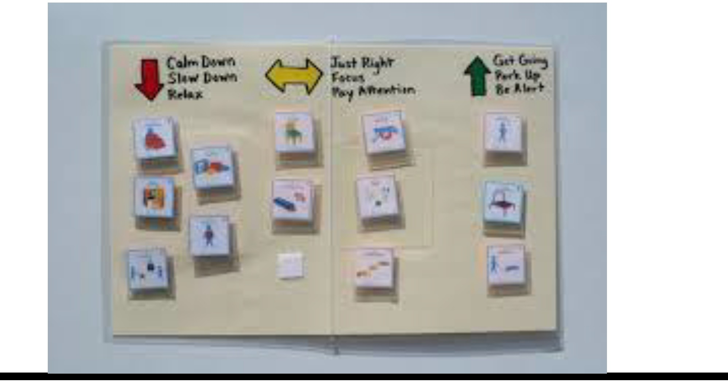

UNIVERSITY OF
LOUISVILLE.
KENTUCKY AUTISM .
TRAINING CENTER

Evidence-Based Practice (EBP)
• A practice that is supported by multiple high-quality
research studies

Why are EBPs important?
• Ensure we have the sharpest tools at our disposal
• We have a rationale for selecting intervention
• We can avoid the pitfalls of fad interventions

The NPDC has identified 27 Evidence-Based Practices

• Evidence-Based Practice Briefs
• http://autismpdc.fpg.unc.edu/content/briefs
• AIM – Autism Internet Modules
• www.autisminternetmodules.org

Evidence-Based Practices

• Antecedent Based Intervention
• Cognitive Behavioral Intervention
• Differential reinforcement
• Discrete trial teaching
• Exercise
• Extinction
• Functional behavior assessment
• Functional communication training
• Modeling
• Naturalistic interventions
• Parent-implemented intervention
• Peer-mediated instruction/intervention
• Picture Exchange Communication
System™
• Pivotal response training
• Prompting
• Reinforcement
• Response interruption/redirection
• Scripting
• Self-management
• Social narratives
• Social skills training
• Structured play groups
• Task analysis
• Technology-aided instruction/intervention
• Time delay
• Video modeling
• Visual supports

LOUISVILLE Kentucky Autism Training Center
UNIVERSITY OF

Sensitive Sam

Sam's sensory adventure has
a happy ending!
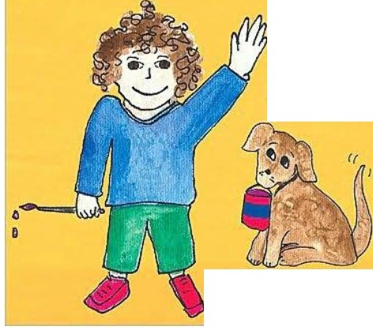

Wr1tten d. •llustrotcd by
Marla Roth-Fisch

Carol Slo..d.l.K..t8,1.'.1.0.W.,II1,.•M•.oA.

I
-Picley, Pic\Cy Pete
A BoY and His
Sensory Challenges

by Michele Gri ·n

Activitie for ds with ensory Pr oce:. ing Dhordcr

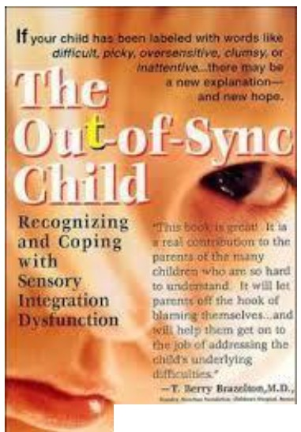

UNI VERS ITY OF
LOUISVILLE.
KENTUCKY AUTISM .
TRAINING CENTER

Helpful Websites

www.sensorysmarts.com

http://www.sensory-processing-disorder.com

www.spdfoundation.net

Sensory Activities

• http://www.learning4kids.net/list-of-sensory-play-ideas/

• https://www.pinterest.com/JeweledRose/kids-sensory-activities/

• http://sensorysmarts.com/sensory_diet_activities.html

References used to create this PowerPoint

• Jereb, Genevieve (2009). Getting Kids in Sync Online
Seminar.
• Kranowitz, Carol Stock, (2005) the Out of Sync Child: Recognizing and Coping with Sensory Processing Disorder
• Miller, Lucy Jane. (2006). Hope and Help for Children with
Sensory Processing Disorder.
• Wilbarger, Patricia. (2006). Sensory Defensiveness: A comprehensive Treatment Approach. Conference manual, Toronto, ON.

• Yack, E., Sutton, S. & Aquilla, P. (1998). Building Bridges through Sensory Integration.

Questions?

Kimberly.howard@kedc.org

