Exercise As An Evidence Based Practice for
Individuals with Autism Spectrum Disorders

Presented by Michelle Antle, Ed.S.

Field Training Coordinator

LOUISVILLE Kentucky Autism Training Center

• Participants will learn the components of an effective exercise intervention plan.

• Participants will learn the importance of using exercise to intervene in an appropriate and positive way to address a wide variety of behaviors.

• Participants will learn how to teach students with ASD how to use exercise to become healthy and productive.

UNIVERSITY OF
LOUISVILLE.
KENTUCKY AUTISM .

Quality Program Indicators

The NPDC has identified 27 Evidence-Based Practices

• Evidence-Based Practice Briefs
• http://autismpdc.fpg.unc.edu/evidence-based-practices

• The center is currently developing a new online resource, Autism Focused Intervention Resources and Modules (AFIRM) that will host self-paced e-learning modules for each of the EBPs.

LOUISVILLE Kentucky Autism Training Center

Criteria for Qualification as an Evidence-Based Practice:

• At least two high quality experimental or quasi-experimental group design articles
- Conducted by at least two different researchers/research groups

OR

• At least five high quality single case design articles

- Conducted by at least three different researchers/research groups

- Having a total of 20 participants across studies

OR

• A combination of at least one high quality experimental or quasi­ experimental group design article and at least three high quality single case design articles

- Conducted by at least two different research groups

THE NATIONAL PROFESSIONAL DEVELOPMENT CENTER ON
AUTISM SPECTRUM DISORDERS
UNIVERSITY OF
LOUISVILLE.
KENTUCKY AUTISM .

l.OUE1SVILLE. Kentucky Autism Training Center

Increase in physicaI exertion as a means of reducing
problem behaviors or increasing appropriate
behavior.

THE NATIONAL PROFESSIONAL DEVELOPMENT CENTER ON
AUTISM SPECTRUM DISORDERS
UNIVERSITY OF
LOUISVILLE.
KENTUCKY AUTISM .

LOUISVILLE Kentucky Autism Training Center

• Self-stimulatory behaviors

• Hyperactivity

• Aggression

• Self-Injurious behaviors

• Depression

• Anxiety

• Gastro-intestinal issues

• Attention issues

• Obesity

• Fine and gross motor skills

• Sensory Processing

• Coordination and Planning

• Slow Reaction Times

• Visual Tracking

l.OUE1SVILLE. Kentucky Autism Training Center

• Types of Exercise

-Programmed & Structured Activities

• Aerobic exercise

• Strength training

LOUISVILLE Kentucky Autism Training Center
UNIVERSITY OF

• Exercise routine on daily basis reduced a variety of challenging behaviors to zero or near zero levels
• 20 minute exercise routine; 2 times per day (start of day; after lunch}
- Jumping on trampoline
- Scooter boards
- Jogging
- Stretching
- Arm curls with weights
• 1minute exercise breaks once per hour
- Yoga poses
- Jogging in place

Cannella-Malone, Tullis, Kazee
(2011)
UNIVERSITY OF
LOUISVILLE.
KENTUCKY AUTISM .

• Increased physical health

• Helps build in structured breaks and time for exercise during the day

• Teaches exercise as a coping skill

• Increases motor functioning

• Social implications

• Promotes self-esteem

l.OUE1SVILLE. Kentucky Autism Training Center

• Never use exercise as a punishment

• Make sure to include as a part of daily routines

• Highly repetitive is GOOD!

UNIVERSITY OF
LOUISVILLE.
KENTUCKY AUTISM .

l.OUE1SVILLE. Kentucky Autism Training Center

AutismClassroomNews.com Acknowledgements to Christine Reeve
Kentucky Autism Training Center

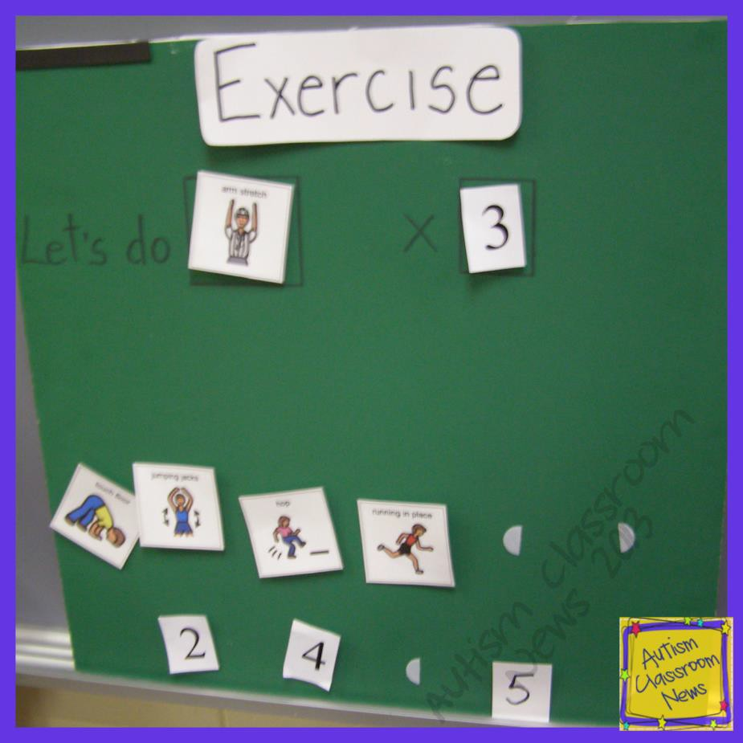

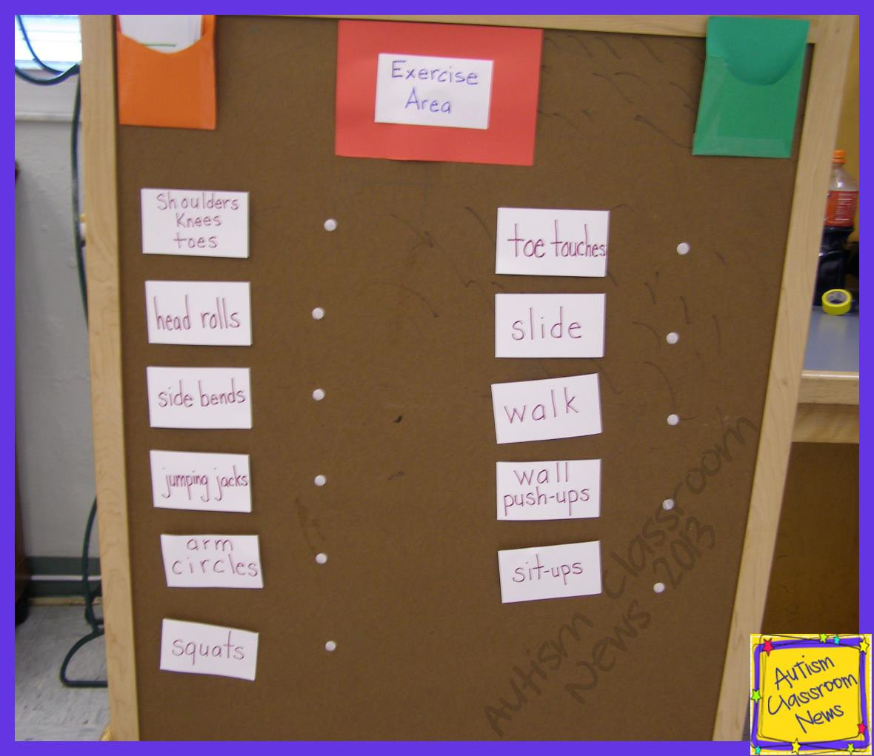 Kentucky Autism Training Center

AutismClassroomNews.com Acknowledgments to Christine Reeve

l.OUE1SVILLE. Kentucky Autism Training Center

LOUISVILLE Kentucky Autism Training Center

• Crawl under chairs

• Log roll across pillows

• Walk a balance beam of duct tape

• Throw a ball in a basket

• Walk with a bean bag on your head

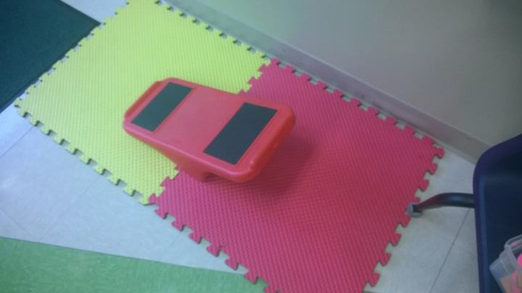
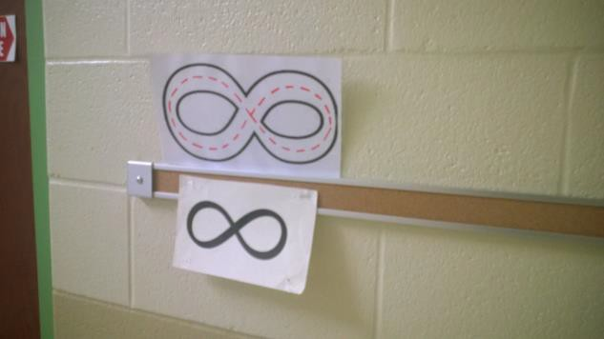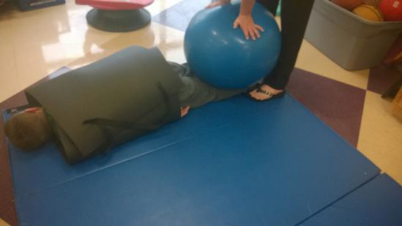A Classroom Example

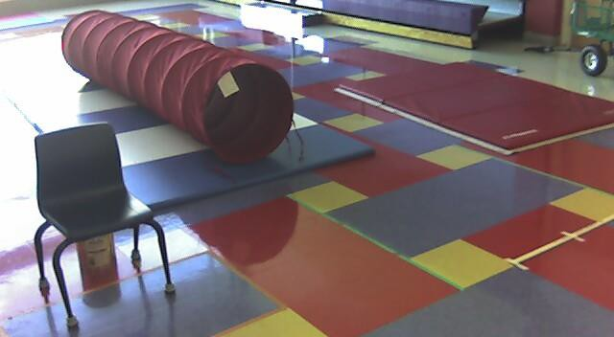

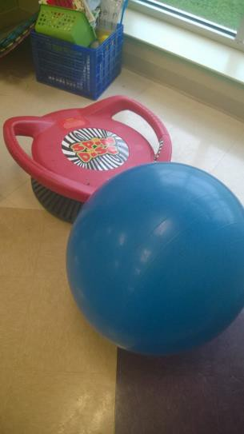

LOUISVILLE Kentucky Autism Training Center

Other Ideas:

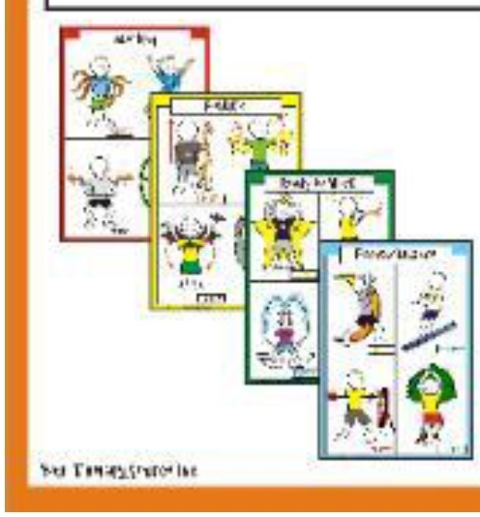• http://www.yourtherapysource.com/cap.html

CLaSsrooM Act.V't
posters

LOUISVILLE Kentucky Autism Training Center
UNIVERSITY OF

• http://www.autismcIa ssroomnews.com

• Cannella-Malone, Tullis, & Kazee {2011}. Using antecedent exercise to decrease challenging behaviors in boys with developmental disabilities and an emotional disorder. Journal of Positive Behavior Interventions, 13{14}, 230-239.
• Wong, Odem, Hume, Cox, Fettig, l<ucharczyk, Brock, Plavnick, Fleury, & Schultz
{2014}. Evidence-based Practices for Children, Youth, & Young Adults with ASD. Autism Evidence-based Practice Review Group. Frank Porter Graham Child Development Institute, University of North Carolina at Chapel Hill.
• http://www.yourtherapysource.com/cap.html

Center contact info:

Telephone: (502) 852-4631
Fax: (502) 852-7148 E- mail:
katc @ louisville.eu https://louisville.edu/e ducation/kyautismtrai ning
Kentucky Autism Training Center
Field Training Coordinators

Contact us…..

Michelle Antle
Michelle.Antle2@ky.gov
(270) 792-7840

Laura Ferguson Laura.ferguson@louisville.edu (502) 852-6403

Kim Howard Kimberly.Howard@KEDC.org (606) 316-6011

