Bullying & Autism

Kimberly Howard M.Ed.

Objectives:

• The participant will leave with an understanding of how bullying impacts the lives of children with autism.

• The participant will leave with an understanding of how to help children with autism that are being bullied.

• The participant will leave with a list of resources and activities to use with children with autism that are at risk for being bullied or are being bullied

Bullying is a repeated pattern of aggressive
behavior that involves an imbalance of power
that purposefully inflicts harm on the bullying
victim (Olweus, 1993).

http://education.ky.gov/school/sdfs/Pages/Bullying.aspx

Federal Laws Regarding Bullying & Disabilities

• Section 504, Title II, and the Individuals with Disabilities Education Act (IDEA),: to ensure that a free appropriate public education (FAPE) is made available to eligible students with disabilities. Disability harassment may result in a denial of FAPE under these statutes

• http://www.wrightslaw.com/info/harassment.index.htm#sthash.2grE
qGR9.dpuf

House Bill 91: The Bullying Bill

School Requirements for Compliance with HB 91 (KRS 158.156) Procedures to be Followed
• School employees report to principal (suspected student victims of felony offenses under KRS
Chapter 508)
• Within 48 hours, principal files written report with local board of education* (through the Superintendent as the executive agent of the BOE), and one of three local law-enforcement agencies (See Section 1)
• Principal notifies parents or guardians of student **
• The agency receiving the principal’s report will conduct an investigation (school and/or board may participate in the investigation if the agency requests)
• If a law or board violation has occurred, school will report incident as part of safe school data reporting

Kentucky Bullying Statics

• 2014-2014 school year there were 20,172 reports of bullying/
harassment

• 71% of reported events happened in grades 6 -10.

• 72% of reported events involved males

http://education.ky.gov/school/sdfs/pages/safe-schools-data-collection-and- reporting.aspx

National Bullying Statistics

• Nearly 1 in 3 students (27.8%) report being bullied during the school year (National Center for Educational Statistics,
2013).

• 64 percent of children who were bullied did not report it;
only 36 percent reported the bullying (Petrosina,
Guckenburg, DeVoe, and Hanson, 2010).

http://www.pacer.org/bullying/about/media-kit/stats.asp

Autism Specific Bullying Statistics

• 63% of 1,167 children with ASD, ages 6 to 15, had been bullied at some point in their lives

http://www.iancommunity.org/cs/ian_research_reports/ian_research_report_bu llying

LOUISVILLE® Kentucky Autism Training Center
UNIVERSITY OF

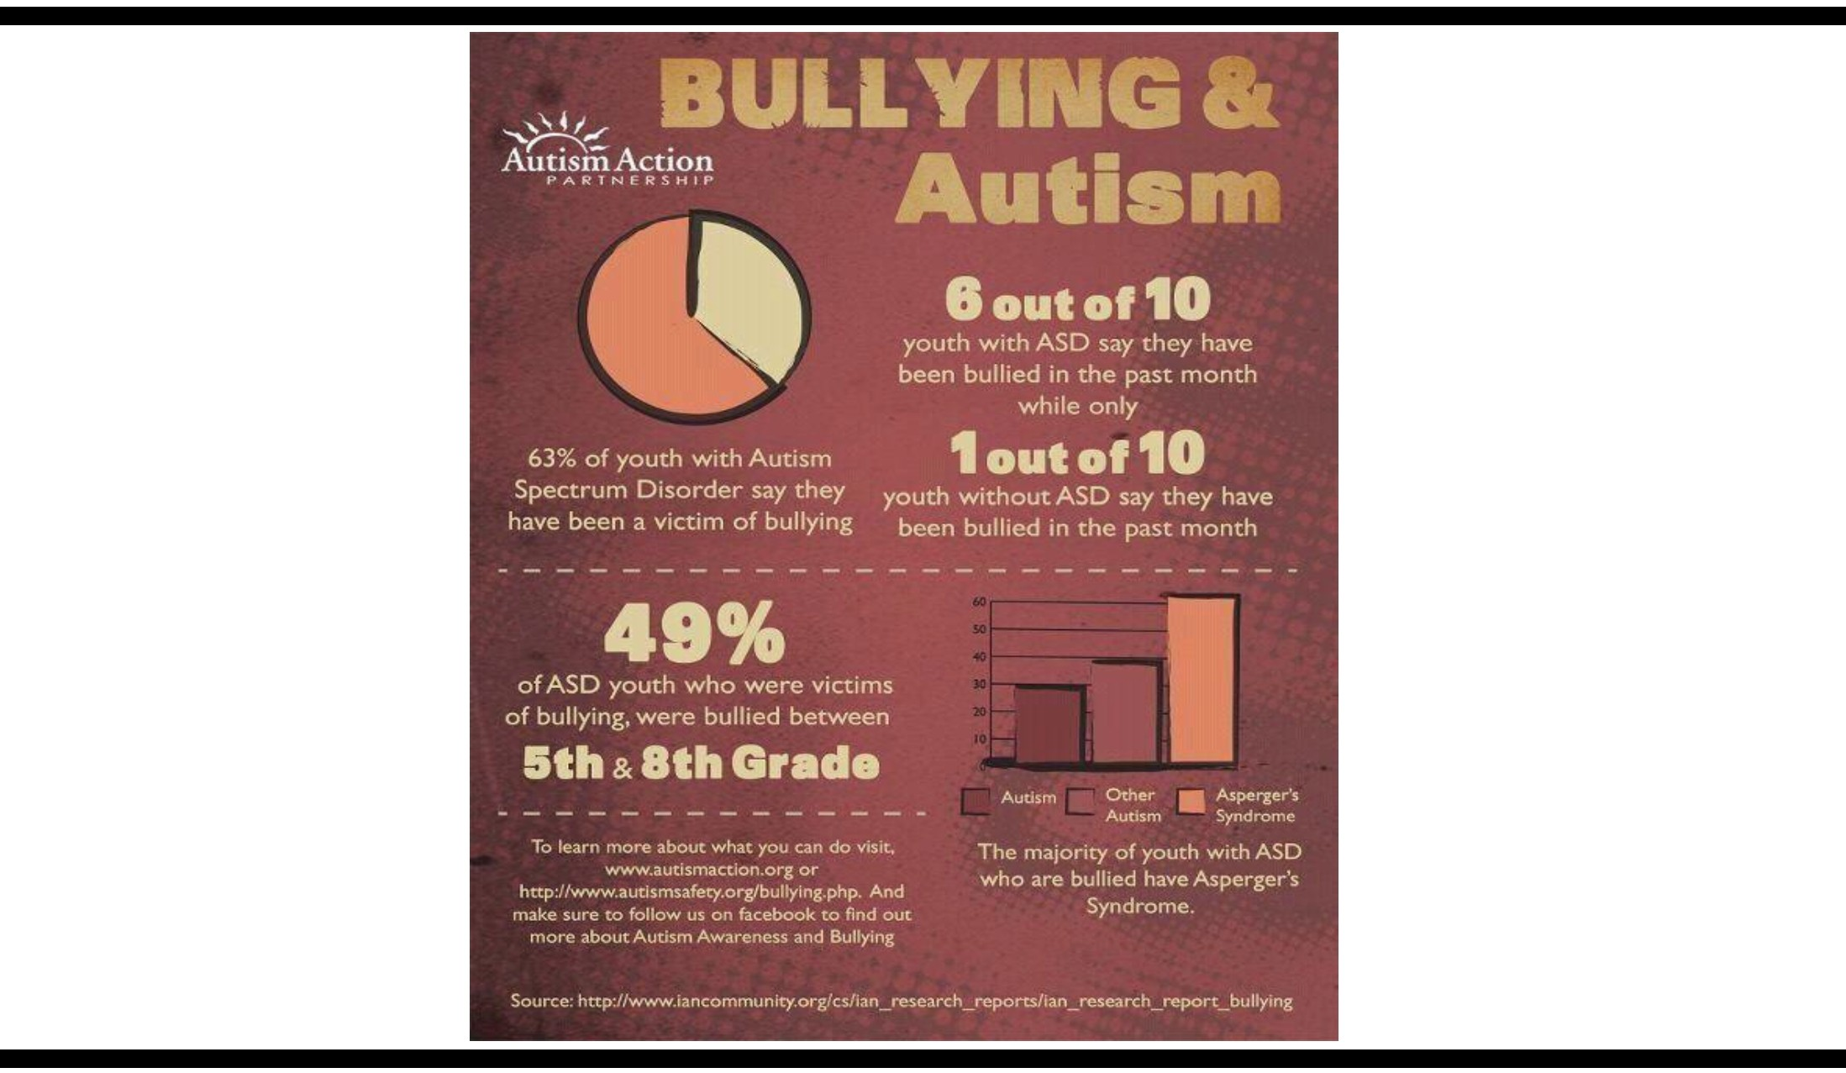
UNIVERSITY OF
LOUISVILLE.
KENTUCKY AUTISM TRAINING CENTER

Why

● Many of the defining characteristics of autism are the ones
that put them at greatest risk of bullying.” Dr. Catherine
Bradshaw

● Often socially awkward

● Difficulty communicating and recognizing social cues

● Strict adherence to rituals and habits

Bullying

● Individuals with ASD may not realize they are being bullied:

● Difficulty understanding sarcasm

● Desire to be liked/have friends

● May equate being bullied to how friendships work

-Brenda Smith-Myles

Ways to Support a Student who is bullied

● Assist the student in identifying sarcasm and bullying

● Help the student practice what to say to the bully so he or she will be prepared the next time

● Help the student practice being assertive. The simple act of insisting that the bully leave him alone may have a surprising effect. Explain to the student that the bully's true goal is to get a response.

● Encourage the student to be with friends when traveling back and forth from school, during shopping trips, or on other outings. Bullies are less likely to pick on a child in a group.

Center for the

WHAT WORKS IN PREVENTING, AND RESPONDING TO, ASD BULLYING.

• School Climate Change
• Safe ways to report (safety net programs)
• Focus on all types of bullying (not just physical aggression)
• Focus on role of bystanders
▪ Peer support networks
• Adults model supportive relationships
• Active parent involvement

WHAT Doesn't Work IN PREVENTING, AND
RESPONDING TO, ASD BULLYING
• Individual counseling (for bully or victim)
• Accepting bullying as normal
• Focusing on only physical aggression
• Zero tolerance policies
• Isolated efforts (special auditorium events, lectures)
• Stigmatizing victims
▪ Adults model intimidation, anger, power

Source: What Works, What Doesn’t Work in Bullying Prevention Strategies. Michael B. Greene, Ph.D.
Director, YCS Center for the Prevention of Violence.

Potential Effects of Bullying:
• Health issues

• Depression & Anxiety

• Decreased academic achievement

• Increased absences

http://www.stopbullying.gov/at-risk/effects/

It is not up to one person to end the bullying
it has to be a community effort. We all have a
role to play.

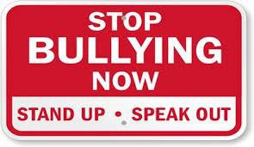

Adult Response is so Important!!

• Adults should listen without judgment

• Adults should make sure that parents are informed

• Adults should provide a safe place to talk about what has happened and help decide what next steps should be taken

http://www.pacer.org/publications/bullypdf/bp-18.pdf

Self Advocacy

Students with disabilities must be taught to recognize bullying and steps to take if it is happening to them.

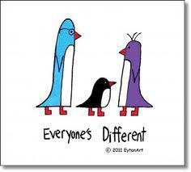

UNIVERSITY OF
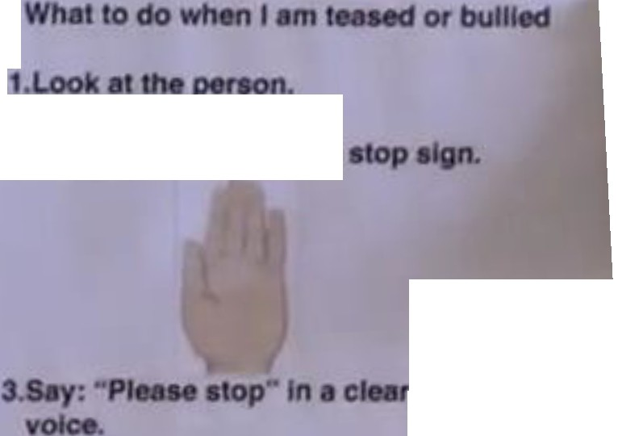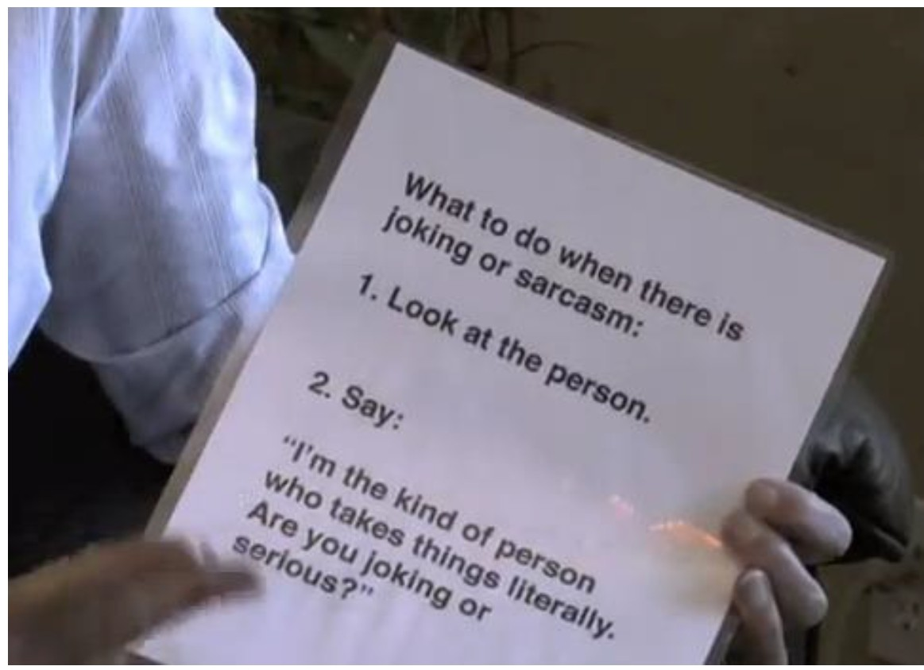LOUISVILLE® Kentucky Autism Training Center

2.Hold up "" tiMd •

• firm

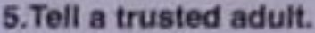

UNIVERSITY OF
LOUISVILLE.
KENTUCKY AUTISM TRAINING CENTER

We must teach peer’s how to respond to
witnessing others being bullied!

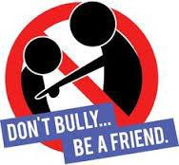

Bystanders have Power!!

• Peers are much more likely to see what is happening to peers than adults are.

• Peer influence can be powerful

How can Bystanders Help?

• Tell a trusted adult.

• Be their friend.

• Don’t give bullies an audience!

• Don’t spread rumors.

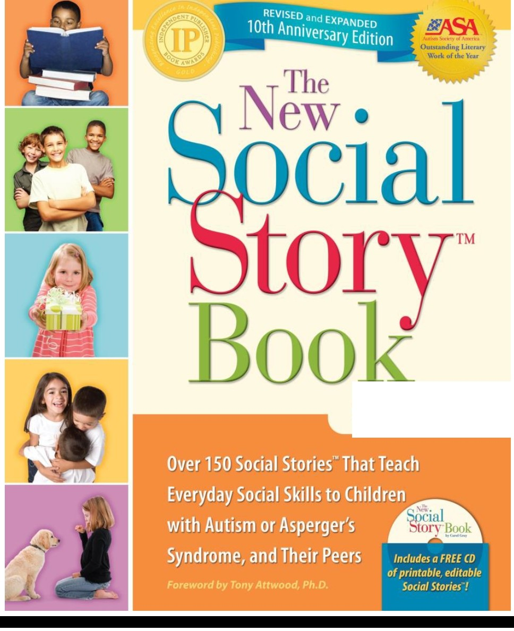 LOUISVILLE® Kentucky Autism Training Center
UNIVERSITY OF

by Carol Gray

UNIVERSITY OF
LOUISVILLE.
KENTUCKY AUTISM TRAINING CENTER

Children Literature that looks at Bullying

http://www.chicagonow.com/portrait-of-an-
adoption/2012/04/anti-bullying-reading-
recommendations-for-children-and-teens/

Children Literature that looks at Bullying

http://www.chicagonow.com/portrait-of-an-
adoption/2012/04/anti-bullying-reading-
recommendations-for-children-and-teens/

Printable teaching tools

• http://autismteachingstrategies.com/free-social-skills- downloads-2/

• http://autismteachingstrategies.com/autism- strategies/autism-strategies-communication/words-hurt- words-help-3/

• http://autismteachingstrategies.com/autisstrategies/teasi ng-and-bullying-social-skills-kit-for-kids-with-asd-free- download-cards-and-illustrated-panels/

Whole Class Toolkits for Bullying Prevention

• http://safesupportivelearning.ed.gov/training-technical- assistance/training-products-tools/training-toolkits

• http://specialneeds.thebullyproject.com/educators

• http://www.bystanderrevolution.org/

Autism Specific Resources

• http://specialneeds.thebullyproject.com/

• https://www.autismspeaks.org/family-services/bullying

Resources

• https://www.kycss.org/bullying.php

• http://education.ky.gov/school/sdfs/Pages/Bullyin g.aspx

• http://stopbullyingnow.com/

Resources
• http://www.modelmekids.com/bully.html

• https://www.pinterest.com/pin/AQ5RclVnlSLEKpEb3Aforj- DwbVBvaAFnCFq2JHp3Irfe5xcvT0bPgo/

• https://www.pinterest.com/pin/77968637275246464/

Questions?

Kimberly.howard.1@louisville.edu

