KEEP Purposeful Practices
Advancing Outcomes for All Learners
“High-leverage practices are the basic fundamentals of teaching. These practices are used constantly and are critical to helping students learn important content…these high-leverage practices are used across subject areas, grade levels, and contexts. They are ‘high-leverage’ not only because they matter to student learning but because they are basic for advancing skill in teaching.” (teachingworks.org)
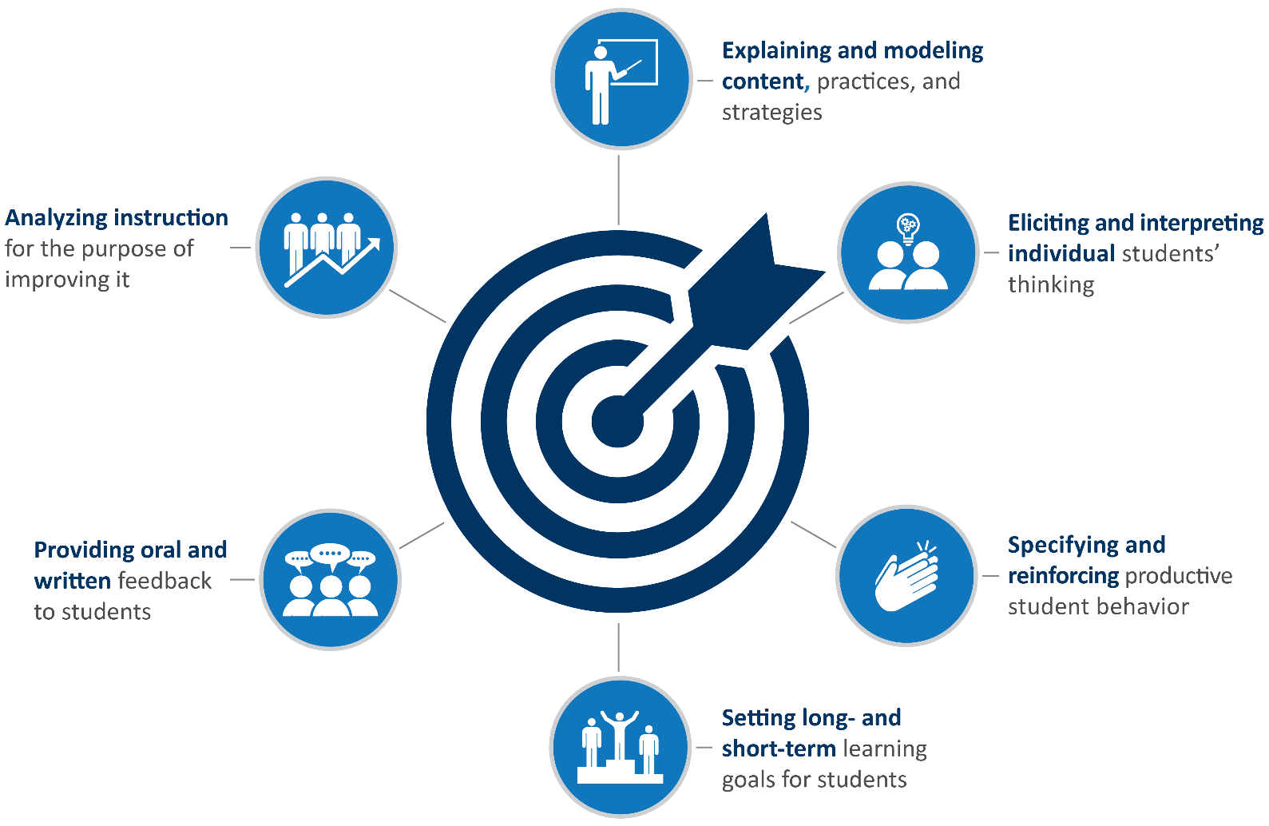

Overview of KEEP (Kentucky Excellence in Educator Preparation) HLPs (High-Leverage Practices)
High-Leverage Practice | Description
Explaining and modeling content, practices, and strategies | Explaining and modeling are practices for making a wide variety of content, academic practices, and strategies explicit to students. Depending on the topic and the instructional purpose, teachers might rely on simple verbal explanations, sometimes with accompanying examples or representations. In teaching more complex academic practices and strategies, such as an algorithm for carrying out a mathematical operation or the use of metacognition to improve reading comprehension, teachers might choose a more elaborate kind of explanation that we are calling “modeling.” Modeling includes verbal explanation but also thinking aloud and demonstrating.
Eliciting and interpreting individual students’ thinking | Teachers pose questions or tasks that provoke or allow students to share their thinking about specific academic content in order to evaluate student understanding, guide instructional decisions, and surface ideas that will benefit other students. To do this effectively, a teacher draws out a student’s thinking through carefully chosen questions and tasks, and considers and checks alternative interpretations of the student’s ideas and methods.
Specifying and reinforcing productive student behavior | Clear expectations for student behavior and careful work on the teacher’s part to teach productive behavior to students, reward it, and strategically redirect off-task behavior help create classrooms that are productive learning environments for all. This practice includes not only skills for laying out classroom rules and managing truly disruptive behavior, but for recognizing the many ways that children might act when they actually are engaged and for teaching students how to interact with each other and the teacher while in class.
Setting long- and short-term learning goals for students | Clear goals referenced to external standards help teachers ensure that all students learn expected content. Explicit goals help teachers to maintain coherent, purposeful, and equitable instruction over time. Setting effective goals involves analysis of student knowledge and skills in relation to established standards and careful efforts to establish and sequence interim benchmarks that will help ensure steady progress toward larger goals.
Providing oral and written feedback to students | Effective feedback helps focus students’ attention on specific qualities of their work; it highlights areas needing improvement and delineates ways to improve. Good feedback is specific, not overwhelming in scope, focused on the academic task, and supports students’ perceptions of their own capability. Giving skillful feedback requires the teacher to make strategic choices about the frequency, method, and content of feedback and to communicate in ways that are understandable by students.
Analyzing instruction for the purpose of improving it | Learning to teach is an ongoing process that requires regular analysis of instruction and its effectiveness. Teachers study their own teaching and that of their colleagues in order to improve their understanding of the complex interactions between teachers, students, and content and of the impact of particular instructional approaches. Analyzing instruction may take place individually or collectively and involves identifying salient features of the instruction and making reasoned hypotheses for how to improve.

