What is the Louisville Writing Project?

We are a teacher network focused on developing teacher leaders in writing and all other aspects of literacy. LWP is affiliated with the National Writing Project (federally funded 1991-2011), a network of 185 sites across the country and abroad (www.nwp.org)
LWP works with schools to provide and promote professional development in literacy for teachers of all grade levels and content areas. We seek to
—improve literacy skills among students;
—support teachers in understanding and implementing the Common Core Standards for Literacy in English/Language Arts, History/Social Studies, Science, and Technical Subjects;
—increase understanding of literacy assessment methods;
—enhance literacy instruction at all levels, in all subjects;
—recognize and promote teacher expertise in the teaching of writing and reading; and
—increase literacy collaboration and communication among all teachers, P-12.

In addition to the Summer Institute for Leadership Development, we offer a school-year LWP Leadership Academy and contracted teacher professional development to schools to promote best practices in literacy and to enhance student achievement in all grade levels and contents.
Basic Assumptions of the
Writing Project Model

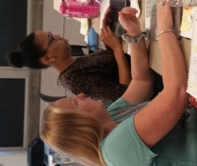
- Writing is fundamental to learning. Summer Institutes therefore involve teachers from all disciplines and levels of instruction, primary through university.
- As the process of writing can best be understood by engaging in that process, teachers of writing should write. The summer institute focuses in part on teachers as writers.
- Teachers are the best teachers of teachers; successful practicing teachers have greater credibility with their colleagues than outside experts. A central part of the summer institute involves participants presenting their best lessons to one another.
- Real change in classroom practice happens over time. Working as partners, universities and schools can articulate and promote effective school reform. The school year component of the institute therefore involves teachers sharing what they have learned with their colleagues.
- Effective professional development programs are on-going and systematic, bringing teachers together regularly throughout their careers to examine successful practices and new developments (NWP, 1998). LWP therefore offers lifelong PD, with members taking on leadership to sustain the network.

LWP also sponsors advanced institutes, graduate courses in literacy, study groups, book groups, writing groups, in-school professional development, miniconferences, teacher publications, and social events for our members.
https://louisville.edu/education/centers/nystrand/lwp

Eligibility for LWP Invitational Institute
LWP seeks P-20 educators/ (both teachers and administrators) from a 10-county service area around UofL. Criteria for selection include
—2+ years’ successful P-12 or university teaching experience (any content area);
—strong recommendation plus commitment from principal/supervisor to provide candidate with leadership opportunities;
—potential for and commitment to improving teaching practices in writing and in assuming leadership roles;

—well-prepared application and successful interview; and
—commitment to share your expertise through a demonstration lesson; to develop your skills as a presenter; to read, write, and research in order to improve your teaching; and to participate actively in the network.
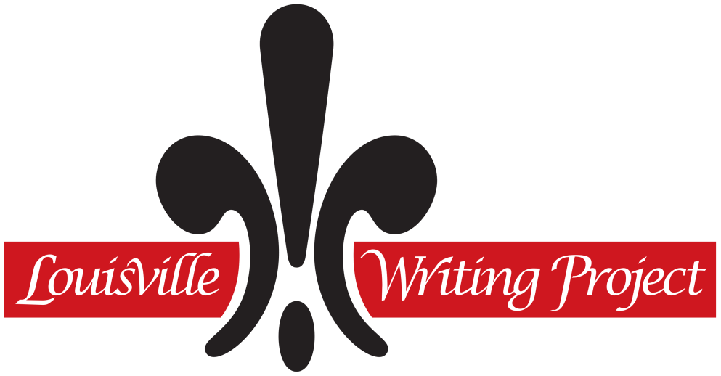

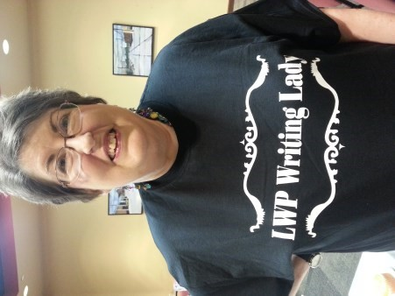
n
Applications
due March 20

Applications available at

•

http://louisville.edu/education/centers/
nystrand/lwp/

•

or by email (send request to
lksatt01@louisville.edu)

Required Time Commitments:

March 20: Applications due

Late March: Interviews, by appointment appointment

April 27-28: Required “Boot Camp” Orientat

May: Coaching appointments (TBA)

June 11-22: Summer Institute, 8-3:30 Monday through Friday + 1 evening potluck

2 LWP Conferences (September and January)
2 State Conferences (KWP & KCTE/LA)

6 Saturday Sessions during the school year
-

Summer 2019 Retreat

Note: Credit recorded June 2019

To contact the Louisville Writing Project, please call or email:
Phone: 502-852-4544
Fax: 502-852-4634
E-mail: jean.wolph@louisville.edu

Nystrand Center for Excellence in Education
Porter College of Education & Human Development, Room 105
1905 S. 1st Street
University of Louisville
Louisville, KY 40292

LWP

LEADERS IN LITERACY

Louisville
Writin
g
Project

2018-19 Institute for
fo
Literacy Leadership Development

June 11-22, 2018, 8:00-3:30

Sponsored by the Nystrand Center for Excellence in Education in the College of Education & Human Development at the University of Louisville. Member site of the National Writing Project and the Kentucky Writing Project Network.

