Overview of ScICAM

Science Inquiry Centered Argumentation Model (ScICAM) is a systematic approach that integrates literacy instruction in the context of active, argument-based inquiry science learning for students grades K-2.

The ScICAM Approach
The ScICAM approach is a K-2 adaptation of the Science Writing Heuristic (SWH; Hand & Keys, 1999; Hand, 2008). The approach—demonstrated as successful with native English-speaking students of varied ages (e.g., Burke, Poock, Greenbowe, & Hand, 2005; Shelley, Gonwa-Reeves, Baenziger, Hand, & Therrien, in press)—builds on a rich history of research on ways to integrate literacy and science (e.g., Bereiter & Scardamalia, 1987; Keys, 1999). Unlike its predecessors, the approach is more of an argumentation structure that assists students in engaging in the thinking and the language use of scientists. The approach provides (a) students with a template to guide science activity while using language and literacy as learning tools and (b) teachers with a template of suggested strategies to guide student learning.

The ScICAM Theoretical Model
In previous research investigating teachers’ embedding of language practices into science inquiry, the researchers used Halliday’s (1975) learning theory to frame their work by thinking about how children learn science through three learning processes centered around science inquiry: (1) living the language of science, building deeper understandings and communication skills about science concepts from background experiences, (2) learning through the language of science, language use in the act of inquiry, explanation, and communication serves as a catalyst for deepening understanding, and (3) learning about the language of science, explicit instruction in language and literacy skills allows students to attach words to experiences, reflect on their thinking, exchange ideas, and build knowledge of language forms for explanation and communication of science ideas.
These learning processes, in turn, are and supported by three key classroom structures: (1) teacher as decision maker, instructional decisions “capitalize on children’s intellectual, linguistic and cultural knowledge to expand possibilities for learning” (Whitmore, Martens, Goodman, & Owocki, p. 319), (2) collective zone of proximal development, learning is seen as an act of personal and social negotiation of meaning (Vygotsky, 1978), and (3) symmetric power and trust relationships, teachers enact an approach in which students control learning (Moll & Whitmore, 1996). The figure below displays a graphic representation of the ScICAM theoretical model.

We are particularly interested in how the ScICAM approach may support science learning of grades K-2 English Learners(EL).
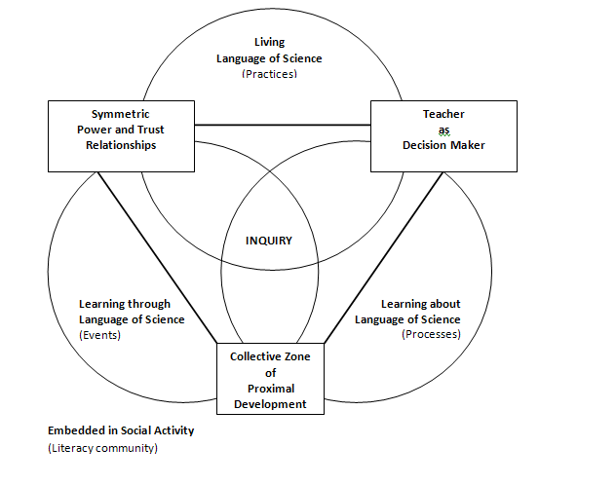
ScICAM Theoretical Model

See the links below for additional information.

Links to:
Alignment between:
- ScICAM Theoretical Model,
- Research Base on supporting English Learners,
- ScICAM Active Ingredients, and
- Next Generation Science Standards (NGSS) Science Practices

Vignette – 1st Grade ScICAM Lesson ‘Pushing on Air’

References
Bereiter, C., & Scardamalia, M. (1987). The psychology of written composition. Hillsdale, NJ: Lawrence Erlbaum Associates.
Burke, K., Poock, J., Greenbowe, T., & Hand, B. (2005). Training chemistry teaching assistants to use the science writing heuristic. Journal of College Science Teaching, 35(1), 36-41.
Halliday, M. A. K. (1975). Learning how to mean. London: Edward Arnold.
Hand, B. (Ed.) (2008). Science Inquiry, Argument and Language: The case for the Science Writing Heuristic (SWH). Rotterdam, the Netherlands: Sense Publishers.
Hand, B., & Keys, C. (1999). Inquiry investigation. The Science Teacher, 66(4), 27–29.
Keys, C. (1999). Revitalizing instruction in scientific genres: Connecting knowledge production with writing to learn in science. Science Education, 83, 115-130.
Moll, L. C., & Whitmore, K. F. (1996). Vygotsky in Classroom practice: Moving from individual transmission to social transmission. In E. A. Forman, N. Minick, & C. A. Stone (Eds.), Contexts for learning: Sociocultural dynamics in children's development (pp. 19–42). New York: Oxford University Press.
Shelley, M., Gonwa-Reeves, C., Baenziger, J., Hand, B., & Therrien, W. J. (in press). Proceedings from Modeling Outcomes for Elementary Science Education: The Science Writing Heuristic Project. Alexandria, VA: American Statistical Association.
Vygotsky, L. V. (1978). The mind in society. Cambridge, MA: Harvard University Press.
Whitmore, K. F., Martens, P., Goodman, Y. M., & Owocki, G. (2005). Critical lessons from the transactional perspective on early literacy research. Journal of early childhood literacy, 4(3), 291-325.

