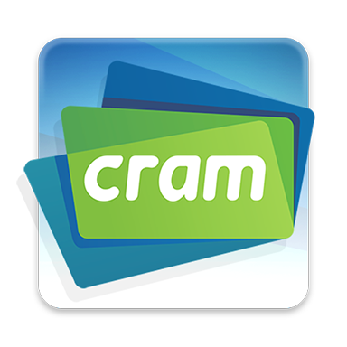

What is it?
Cram has a wide selection of flashcards for students to study in a variety of majors and programs. You or your students can also use Cram create your own web-based flashcard set.

How do I get it?

Visit the Cram website at www.cram.com to create an account. An app version is also available for iOS and Android.

How do I use Cram?
Either search for existing flash card sets or create your own. If you create your own set or instruct your students to do so, follow the instructions below:

1) Type in a title for the card set
2) Include an optional subject area
3) Opt to either make access private or public
4) Include an optional description
5) Begin typing in the front and back of each flash card (images can be included)
6) Select Create to create the flash card set
7) You can then select to share your flash cards via email or print them

How can I use Cram for classroom instruction?
You could create a flash card (or use an existing one) as an exercise in your in-person courses and have your students get in groups to discuss the answers. For your online courses, you could share your flash card set for your students to review individually and/or in a group format. Further, you could assign your students to create their own flash card sets on a topic you have discussed in the course.

What resources can help me get started?
Review an FAQ on Cram at https://www.cram.com/docs/help

